OPERATING SYSTEMS ASSIGNMENT 2 – CO2
CO2 Coverage: Analyse process management and deadlock-handling techniques to improve CPU utilisation and system performance – processes, process scheduling, threads, inter-process communication, synchronisation using semaphores, monitors and the critical-section problem, and deadlock handling including the Banker’s algorithm.
Nature of Assignment: Individual
Duration: 1 Week
Total Marks: 50
Submission Date:
Bloom’s Levels Assessed: K5 – Evaluate (every task in this assignment is at K5 level)
Mandatory Execution and GitHub Submission
- Every student must individually execute every task in this assignment, including all “Complete the Code” programs.
- Create a GitHub repository named CSA04-<RegisterNumber>-Assignment2 and share it with the course faculty (public, or private with the faculty added as a collaborator).
- Keep one folder for each task (for example: Task01, Task02 … or Q1, Q2 …), containing the C source files, shell scripts, configuration files (Dockerfile, YAML), command outputs and screenshots.
- Include a README.md with your name, register number, compiler and version (for example gcc 13), the Linux distribution and version used, the exact gcc command used to compile (for example gcc -std=c11 -Wall -Wextra -pthread), the steps to run each program, and a short note of the result of each task.
- Commit your work progressively – at least one commit for each task. The commit history will be checked; a single upload of all files on the last day will not be accepted.
- Submit the GitHub link below and on the cover page of your report. An assignment submitted without a working GitHub link will not be evaluated.

GitHub Repository Link: https://github.com/192524372simats/CSA0413-OS.git
How to Answer the Additional Questions
Complete the Code: Copy the given code into your repository, replace every TODO with working code without changing the rest of the program, execute it and compare your output (or result) with the expected output.
Alternative Concept and Complexity Analysis: Describe how the solution would change if the alternative concept were used, with code or pseudocode, and analyse and compare the time complexity and space complexity of both solutions using Big-O notation, supported by your own measurements wherever possible.

Q1 – Processes and Process States (6 marks)
  - Model: process-state diagram
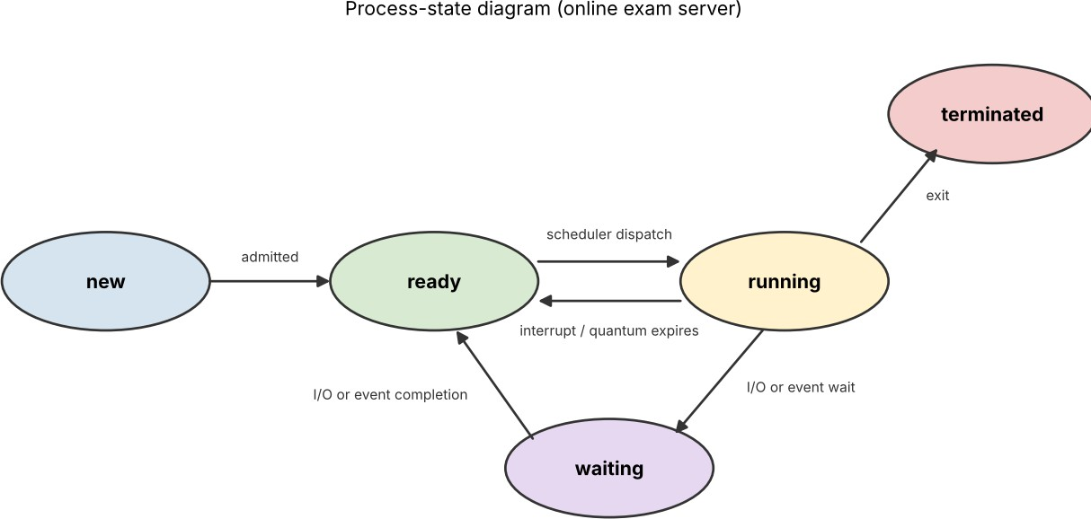

Figure 1 – Five-state process model. A session runs only in the running state; waiting for the disk, network or keyboard moves it to waiting, which frees the CPU for others.

Model: process control block (PCB)
The PCB is the kernel's record of one process (task_struct in Linux). It is what the kernel saves and restores at a context switch.

PCB field | Contents | Exam-server example
Process ID / parent ID | Unique number, creator | Session process 122, parent 120
Process state | new, ready, running, waiting, terminated | State: S (sleeping) = waiting
Program counter + CPU registers | Saved when the process leaves the CPU | Resumes the exam-answer handler
CPU-scheduling information | Priority, queue pointers, time used | Student sessions at normal priority
Memory-management information | Page-table base, segment limits | Private address space (page tables)
Accounting information | CPU time, time limits, counters | voluntary_ctxt_switches: 1
I/O status  information | Open-file table, devices allocated | Socket to the student's browser, answer file

Implement: fork() program observed with ps and /proc
The program creates four children with fork(). Children 0–2 sleep (waiting state); child 3 exits at once and is not reaped, so it shows as a zombie (Z) – a terminated process whose PCB is still held by the kernel. The parent then runs ps and reads
/proc/<pid>/status.
Q1/fork_demo.c
#define _POSIX_C_SOURCE 200809L #include <stdio.h>
#include <stdlib.h> #include <unistd.h> #include <sys/wait.h>
/* Q1: create child "student sessions" with fork(), observe with ps and /proc */ int main(void) {
const int N = 4; pid_t kids[4];
for (int i = 0; i < N; i++) { pid_t pid = fork();
if (pid == 0) { /* child = one student session */
if (i == 3) _exit(0); /* exits at once, parent has not reaped it -> zombie (terminated) */
sleep(3); /* others sleep -> WAITING state */
_exit(0);
}
kids[i] = pid;
}
sleep(1);
printf("parent pid=%d created children:", getpid()); for (int i = 0; i < N; i++) printf(" %d", kids[i]);
printf("\n\n--- ps -o pid,ppid,stat,vsz,rss,comm (parent + children) ---\n"); char cmd[256];
snprintf(cmd, sizeof cmd, "ps -o pid,ppid,stat,vsz,rss,comm --ppid %d --pid
%d", getpid(), getpid()); fflush(stdout); system(cmd);
printf("\n--- /proc/%d/status of child 0 (PCB fields) ---\n", kids[0]); snprintf(cmd, sizeof cmd, "grep -E
'Name|State|^Pid|PPid|VmSize|VmRSS|voluntary_ctxt|nonvoluntary_ctxt'
/proc/%d/status", kids[0]); fflush(stdout); system(cmd);
for (int i = 0; i < N; i++) waitpid(kids[i], NULL, 0); printf("\nall children reaped (state: terminated)\n"); return 0;
}

Output
parent pid=120 created children: 122 123 124 125
--- ps -o pid,ppid,stat,vsz,rss,comm (parent + children) ---PID PPID STAT VSZ RSS COMMAND
120 106 S 2692 1744 fork_demo
122 120 S 2560 268 fork_demo
123 120 S 2560 268 fork_demo
124 120 S 2560 268 fork_demo
- 120 Z 0 0 fork_demo
- 120 S 2812 1908 sh
--- /proc/122/status of child 0 (PCB fields) ---Name: fork_demo
State: S (sleeping) Pid: 122
PPid: 120
VmSize: 2560 kB
VmRSS: 268 kB
voluntary_ctxt_switches: 1
nonvoluntary_ctxt_switches: 0
all children reaped (state: terminated)

Reading the evidence: PPID 120 shows every child was created by the parent; STAT S is the waiting state; STAT Z is the terminated-but-not-reaped state;
/proc/122/status exposes PCB fields (State, Pid, PPid, VmSize, VmRSS, context-switch counters).
  - Evaluate: where does the time go with 2,000 active processes? Measured (Q1/bench_proc_vs_thread.c and Q1/memtest.c)
fork+wait (parent holds 64MB): 878.7 us per process pthread_create+join : 12.0 us per thread
process context switch (pipe ping-pong, 1 CPU): 1.32 us 1000 forked processes : 83520 KB extra (84 KB each) 1000 threads : 34152 KB extra (34 KB each)

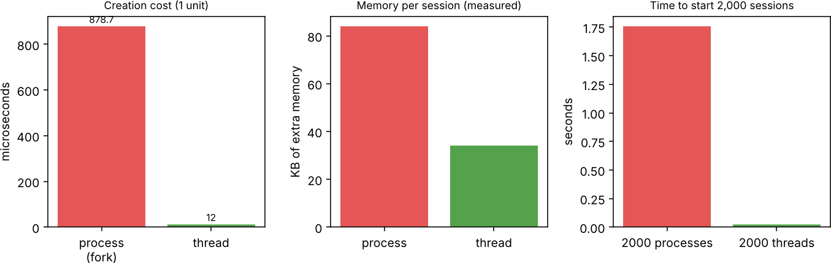
Figure 2 – Creation cost, memory and start-up time for one session as a process versus as a thread.

Cost | Measurement | Consequence for 2,000 sessions
Starting a process (fork, parent holds 64 MB) | ≈ 879 µs | 2,000 × 879 µs ≈ 1.76 s of pure creation time during the login storm
Context switch between processes | ≈ 1.3 µs (pipe ping-pong, upper bound: includes 2 system calls) | With 2,000 runnable sessions and a 4 ms slice, switching itself is cheap; the loss is cache and TLB refill after each switch
Memory per process (kernel structures + page tables,  minimum) | ≈ 84 KB | ≈ 168 MB before any application data; a real session with its own heap/runtime of tens of MB gives tens of GB
Waiting for I/O | Sessions spend most of their life in the waiting state (typing, network, auto-save) | The CPU is idle while memory is occupied: memory, not CPU, is the bottleneck. Sessions that "hang" are normally swapped out or starved of memory

Judgement: one process per student is easy to write and gives excellent isolation, but it does not scale: creation, memory and page-table cost grow linearly with sessions while each session is mostly idle. It is not a sound design for 2,000 simultaneous logins.

Design decision

Option | Creation | Memory/session | Isolation | Verdict
One process per student | ≈ 879 µs | ≈ 84 KB  minimum, MBs real | Excellent | Too heavy at 2,000
One thread per student | ≈ 12 µs | ≈ 34 KB (stack) | None – one fault kills all | Cheap but risky
Fixed pool of worker processes (each serving many sessions) | Once, at start-up | Pool size × process cost | A crash loses only that worker's sessions | Chosen

Decision: use a fixed pool of worker processes (about 2 × the number of cores, e.g. 16), each serving many sessions with threads or an event loop, plus one separate process for proctoring video and one for auto-save. This keeps start-up cost constant, memory bounded, and limits a crash to one worker (≈ 1/16 of the students) which the supervisor restarts. A session's state is saved by the auto-save process so a restarted worker can resume it.

Alternative concept and complexity analysis: each session as a thread Pseudocode
main():
create listening socket
for each login: pthread_create(&t, handle_session, conn) // 1 thread = 1 student handle_session(conn):
loop: read answer -> save -> reply // blocks in waiting state during I/O

Criterion | Process per session | Thread per session
Creation time | O(size of address space/page tables): 879 µs measured | O(1): 12 µs measured (≈ 73× faster)
Context switch | Switch address space (TLB flush): ≈ 1.3 µs + cache misses | Same address space: cheaper, no TLB flush
Memory (space) per session | Separate address space; 84 KB minimum | Stack + thread structures; 34 KB measured, a few KB of private data
Total space for n sessions | O(n × address-space size) | O(n × stack size) + one shared heap

Criterion | Process per session | Thread per session
Effect of one session crashing | Only that session dies | A segmentation fault terminates the whole server process: all 2,000 sessions lost
Sharing data (exam questions) | Needs IPC / copies | Shared memory directly; needs locks (Q5)

Both designs are O(n) in time to start n sessions and O(n) in space, but with very different constants (≈ 879 µs and ≥ 84 KB versus ≈ 12 µs and ≈ 34 KB). Threads win on cost; processes win on fault isolation – which is why the pool-of-processes-with-threads hybrid is recommended.

Q2 – CPU Scheduling (8 marks)
  - Workload and method
The same four jobs are used for every algorithm (the data used by the Complete-the-Code program). Priority: 1 = highest. Waiting time = turnaround − burst; turnaround = finish − arrival; response = first CPU − arrival.

Job | Arrival | Burst | Priority
P1 | 0 | 8 | 3
P2 | 1 | 4 | 1
P3 | 2 | 9 | 4
P4 | 3 | 5 | 2

Results were produced by a unit-time simulator (Q2/sched.py) and cross-checked against the C Round Robin program (Section 2.3): both give identical Gantt charts for q = 3.

2.2 Gantt charts and averages for FCFS, SJF, SRTF, priority and Round Robin
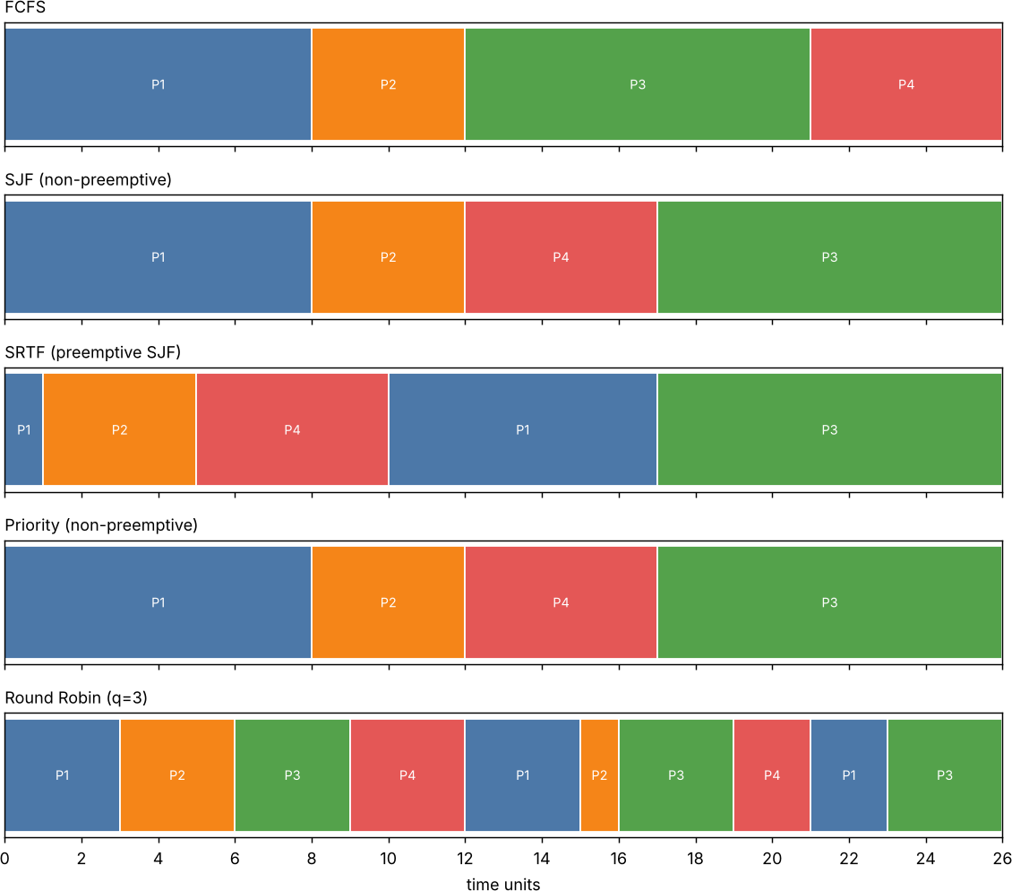
Figure 3 – Gantt charts of the five algorithms for the same job set.

FCFS
Gantt: P1(0-8) P2(8-12) P3(12-21) P4(21-26)

Job | Waiting time | Turnaround time | Response time
P1 | 0 | 8 | 0
P2 | 7 | 11 | 7
P3 | 10 | 19 | 10
P4 | 18 | 23 | 18
Average | 8.75 | 15.25 | 8.75

SJF (non-preemptive)
Gantt: P1(0-8) P2(8-12) P4(12-17) P3(17-26)

Job | Waiting time | Turnaround time | Response time
P1 | 0 | 8 | 0
P2 | 7 | 11 | 7
P3 | 15 | 24 | 15
P4 | 9 | 14 | 9
Average | 7.75 | 14.25 | 7.75

SRTF (preemptive SJF)
Gantt: P1(0-1) P2(1-5) P4(5-10) P1(10-17) P3(17-26)

Job | Waiting time | Turnaround time | Response time
P1 | 9 | 17 | 0
P2 | 0 | 4 | 0
P3 | 15 | 24 | 15
P4 | 2 | 7 | 2
Average | 6.50 | 13.00 | 4.25

Priority (non-preemptive)
Gantt: P1(0-8) P2(8-12) P4(12-17) P3(17-26)

Job | Waiting time | Turnaround time | Response time
P1 | 0 | 8 | 0
P2 | 7 | 11 | 7
P3 | 15 | 24 | 15
P4 | 9 | 14 | 9
Average | 7.75 | 14.25 | 7.75

Round Robin (q=3)
Gantt: P1(0-3) P2(3-6) P3(6-9) P4(9-12) P1(12-15) P2(15-16) P3(16-19) P4(19-21) P1(21-23) P3(23-26)

Job | Waiting time | Turnaround time | Response time
P1 | 15 | 23 | 0
P2 | 11 | 15 | 2
P3 | 15 | 24 | 4

Job | Waiting time | Turnaround time | Response time
P4 | 13 | 18 | 6
Average | 13.50 | 20.00 | 3.00

Summary of averages

Algorithm | Avg waiting | Avg turnaround | Avg response
FCFS | 8.75 | 15.25 | 8.75
SJF (non-preemptive) | 7.75 | 14.25 | 7.75
SRTF (preemptive SJF) | 6.50 | 13.00 | 4.25
Priority (non-preemptive) | 7.75 | 14.25 | 7.75
Round Robin (q=3) | 13.50 | 20.00 | 3.00

SRTF gives the lowest average waiting (6.50) and turnaround (13.00); Round Robin gives the best average response (3.00) but the worst waiting and turnaround, because the quantum makes every job wait for every other job.

Implement: Round Robin (Complete the Code, TODO 1) Q2/rr.c (TODO 1 replaced; the rest of the program is unchanged)
#include <stdio.h>
#define N 4
int main(void) {
const char *name[N] = {"P1", "P2", "P3", "P4"}; int arrival[N] = {0, 1, 2, 3};
int burst[N] = {8, 4, 9, 5}; int quantum = 3;
int left[N], finish[N], queue[64], head = 0, tail = 0, added[N] = {0}; for (int i = 0; i < N; i++) left[i] = burst[i];
int time = 0, done = 0; queue[tail++] = 0;
added[0] = 1; printf("Gantt:"); while (done < N) {
int p = queue[head++];
/* TODO 1 - completed */
int run = left[p] < quantum ? left[p] : quantum; printf(" %s(%d-%d)", name[p], time, time + run); time += run;

left[p] -= run;
for (int i = 0; i < N; i++)
if (!added[i] && arrival[i] <= time) { queue[tail++] = i; added[i] = 1; } if (left[p] > 0) queue[tail++] = p;
else { finish[p] = time; done++; }
}
double tw = 0, tt = 0; printf("\nProcess TAT WT\n"); for (int i = 0; i < N; i++) {
int tat = finish[i] - arrival[i], wt = tat - burst[i]; tt += tat;
tw += wt;
printf("%-7s %4d %3d\n", name[i], tat, wt);
}
printf("Average TAT = %.2f, average WT = %.2f\n", tt / N, tw / N); return 0;
}

Output – identical to the expected output
Gantt: P1(0-3) P2(3-6) P3(6-9) P4(9-12) P1(12-15) P2(15-16) P3(16-19) P4(19-21) P1(21-23) P3(23-26)
Process TAT WT P1 23 15
P2 15 11
P3 24 15
P4 18 13
Average TAT = 20.00, average WT = 13.50

  - Evaluate: time-quantum study (q = 1, 3, 5, 20)
Q2/rr_study.c (same program with the quantum taken from the command line)
== quantum 1
P4 17 12
context switches = 25
Average TAT = 19.00, average WT = 12.50
== quantum 3
P4 18 13
context switches = 9
Average TAT = 20.00, average WT = 13.50
== quantum 5
P4 16 11
context switches = 5
Average TAT = 17.50, average WT = 11.00
== quantum 20
P4 23 18
context switches = 3
Average TAT = 15.25, average WT = 8.75

Quantum | Avg waiting | Avg turnaround | Avg response | Context switches
1 | 12.50 | 19.00 | 0.75 | 25
3 | 13.50 | 20.00 | 3.00 | 9
5 | 11.00 | 17.50 | 5.50 | 5
20 | 8.75 | 15.25 | 8.75 | 3

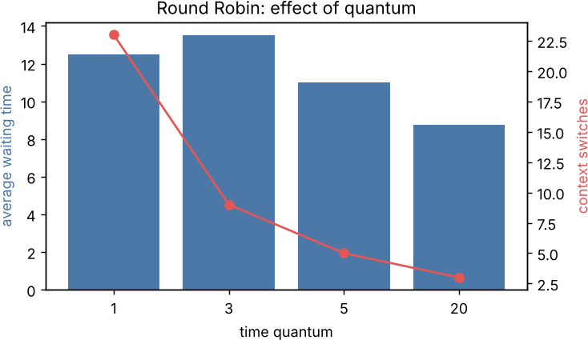
Figure 4 – Effect of the time quantum (switches counted as number of slices − 1, as printed by rr_study).
    - Small quantum (1): best response time (0.75) but 25 context switches; with a real switch cost the overhead becomes large (25 switches × cost).
    - Large quantum (20): Round Robin degenerates into FCFS (3 switches, average waiting 8.75 = the FCFS value) and short jobs wait behind long ones again.
    - Rule of thumb: choose a quantum a little larger than the typical short job (here 5), so most short jobs finish in one slice.

Evaluate: starvation, ageing and the multilevel feedback queue
    - Starvation: in SJF/SRTF a long job can wait forever if short jobs keep arriving; in priority scheduling a low-priority job can wait forever behind a stream of higher-priority jobs.
    - Ageing: the priority of a waiting job is raised by a fixed step every fixed interval (e.g. one level per 10 seconds waiting), so after a bounded time every job reaches the highest priority and runs – starvation is removed.
    - Multilevel feedback queue (MLFQ): new jobs enter the top queue with a short quantum; a job that uses its full quantum is demoted to a queue with a

longer quantum. Short jobs (thumbnails) finish in the top queue; long jobs (films) sink to the bottom queue where they run in long slices. Ageing (promotion of jobs that waited long) prevents starvation of the bottom queue.
  - Alternative concept: multilevel feedback queue for the video service Workload (scaled for simulation: 1 time unit stands for a fixed slice of work; films 200 units, thumbnails 2 units – a ratio of 100:1; the real ratio of 20 min : 2 s is larger, which only strengthens the conclusion): two films F1 (arrives at 0) and F2 (arrives at 5), and six thumbnails arriving at 20, 30, 40, 50, 60 and 70. MLFQ: three queues
with quanta 2, 8 and FCFS.

Policy | Avg waiting – short jobs | Avg waiting – long jobs | Avg waiting – all jobs
FCFS | 360.00 | 97.50 | 294.38
SJF | 160.00 | 103.50 | 145.88
SRTF | 0.00 | 109.50 | 27.38
RR q=5 | 8.33 | 207.00 | 58.00
RR q=20 | 30.00 | 199.50 | 72.38
MLFQ (2/8/FCFS) | 0.00 | 117.00 | 29.25

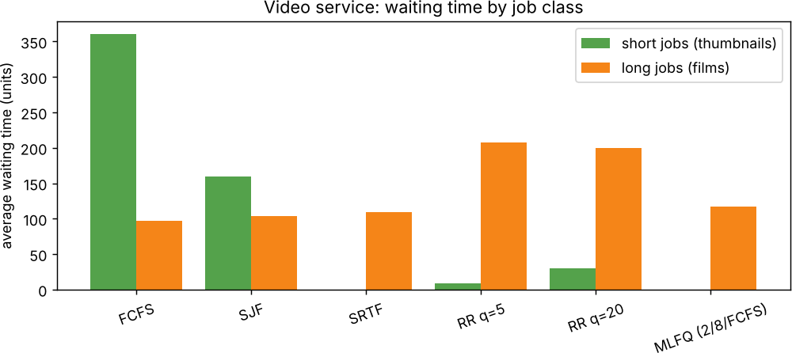
Figure 5 – Waiting time by job class for each policy.

Criterion | Single Round Robin queue | Multilevel feedback queue
Short-job waiting | 8.33 (q = 5), 30.0 (q = 20) | 0.0 – served first, preempts the films
Long-job waiting | 207 (q = 5) – films are sliced evenly and keep being interrupted | 117 – films run in long slices at the bottom

Criterion | Single Round Robin queue | Multilevel feedback queue
Cost per  scheduling decision | O(1): take the head of one queue | O(1) per queue, O(k) for k queues (k = 3 here): scan from the top queue down; SJF needs O(n) to find the shortest job (or O(log n) with a heap)
Needs job lengths in advance? | No | No – learns length by observing quantum use (SJF/SRTF need estimates)
Starvation risk | None | Yes, for bottom-queue jobs under constant short-job load; solved by ageing/promotion

Design decision: recommendation
Recommend the multilevel feedback queue (with ageing). It reaches short-job waiting of 0 and an overall average waiting of 29.25, versus 294.4 for FCFS (the cause of the complaints) and 58.0 for Round Robin with q = 5. SRTF is slightly better on paper (27.4) but needs the run time of each job in advance – unknown for video encoding – and can starve the films. Because the MLFQ keeps the processors fully busy (work-conserving) and gives thumbnails immediate service, it satisfies both the customers and the company's utilisation goal. Pure Round Robin is rejected because it slows long jobs (207) and has no way to favour short jobs.

Q3 – Threads (6 marks)
  - Resources shared and private

Shared by all threads of a process | Private to each thread
Code (text) section | Thread ID
Global and static data, heap | Program counter and CPU register set
Open files, sockets, signal handlers | Stack (local variables, return addresses)
Process ID, address space, current directory | Thread-local storage, errno, signal mask, scheduling priority

User-level and kernel-level threads; multithreading models

Model | Mapping | Advantages | Disadvantages
Many-to-one | Many user threads  → 1 kernel thread (user-level library) | Fast creation and switching, no kernel involvement | One blocking call blocks all threads; no parallelism on multi-core
One-to-one | Each user thread → its own kernel thread (Linux pthreads, Windows) | True parallelism; a blocking call blocks only that thread | Each thread costs a kernel thread; creation is slower (12 µs measured)
Many-to-many | n user threads → m  ≤ n kernel threads | Parallelism and cheap thread creation; scheduler can adapt | Complex to implement; rarely used today

User-level threads are managed by a library without kernel knowledge (fast, but the kernel schedules only the process); kernel-level threads are known to and scheduled by the kernel. POSIX threads on Linux are one-to-one kernel threads.

Implement: 64 cameras with POSIX threads
Each frame needs 20 ms of waiting for the camera (I/O) plus about 5 ms of CPU work for plate recognition. The program processes 64 cameras serially, with one thread per camera, and with pools of 4, 8 and 16 threads that take the next unprocessed camera from a shared counter protected by a mutex.

Q3/cameras.c
#define _DEFAULT_SOURCE #include <stdio.h>

#include <stdlib.h> #include <pthread.h> #include <time.h> #include <unistd.h>
/* Q3: 64 cameras, each frame = I/O wait (grab frame from network) + CPU work (plate recognition).
Modes: serial, one thread per camera, pool of K threads taking cameras from a shared counter. */
#define CAMS 64
#define IO_US 20000 /* 20 ms waiting for the camera frame */ #define WORK 2000000L /* CPU work per frame */
static int next_cam = 0;
static pthread_mutex_t m = PTHREAD_MUTEX_INITIALIZER; static volatile long sink;
static double now(void){struct timespec t;clock_gettime(CLOCK_MONOTONIC,&t);return t.tv_sec+t.tv_nsec*1e-9;} static void process_frame(int cam){
usleep(IO_US); /* blocked: CPU is free for other threads */ long x = cam; for(long i=0;i<WORK;i++) x = x*1103515245L + 12345; sink =
x; /* plate recognition */
}
static void *pool_worker(void *a){ (void)a;
for(;;){ pthread_mutex_lock(&m); int c = next_cam < CAMS ? next_cam++ : - 1; pthread_mutex_unlock(&m);
if(c<0) break; process_frame(c); }
return NULL;
}
static void *one_cam(void *a){ process_frame((int)(long)a); return NULL; } int main(void){
double t0=now(); for(int c=0;c<CAMS;c++) process_frame(c); double ts=now()-t0;
printf("serial (1 thread) : %.3f s speed-up 1.00\n",ts); pthread_t th[CAMS];
t0=now(); for(long c=0;c<CAMS;c++) pthread_create(&th[c],NULL,one_cam,(void*)c);
for(int c=0;c<CAMS;c++) pthread_join(th[c],NULL);
double t=now()-t0; printf("one thread per camera : %.3f s speed-up
%.2f\n",t,ts/t);
int pools[]={4,8,16}; for(int k=0;k<3;k++){
next_cam=0; int K=pools[k]; t0=now();
for(int i=0;i<K;i++) pthread_create(&th[i],NULL,pool_worker,NULL); for(int i=0;i<K;i++) pthread_join(th[i],NULL);
t=now()-t0; printf("pool of %2d threads : %.3f s speed-up %.2f\n",K,t,ts/t);
}
return 0;

}

Output (run 1 of 3)
serial (1 thread)
: 1.616 s speed-up 1.00
one thread per camera : 0.349 s speed-up 4.62 pool of 4 threads : 0.519 s speed-up 3.11
pool of 8 threads : 0.398 s speed-up 4.06
pool of 16 threads : 0.361 s speed-up 4.47

Configuration | Mean time of 3 runs (s) | Speed-up
Serial | 1.617 | 1.00
64 threads (one per camera) | 0.343 | 4.71
Pool of 4 | 0.519 | 3.12
Pool of 8 | 0.388 | 4.17
Pool of 16 | 0.349 | 4.63

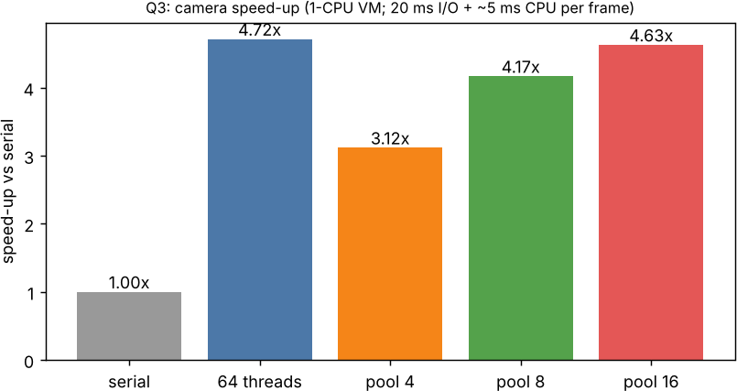
Figure 6 – Measured speed-up for each thread-pool size (mean of 3 runs).
Why the speed-up stops: the machine used has one CPU, so only the 20 ms waiting part of each frame can overlap; the ≈ 5 ms of CPU work cannot run in parallel. The limit is therefore about (20 + 5) / 5 ≈ 5 (serial time per frame ≈ 25 ms), and the curve flattens just below it (≈ 4.6–4.7 for 16 threads and for 64 threads; thread start-up and timer granularity explain the small gap). This is Amdahl's law with the CPU-bound part acting as the serial fraction. On a machine with c cores the CPU part also shrinks by up to c, and then the speed-up is limited by the number of cores, by the 64 cameras, and by thread-management overhead and lock contention on the shared

counter. A pool of 4 is below the limit because 4 threads cannot hide enough waiting; a pool of 8–16 reaches it, and more threads than cameras add nothing.

Shared counters without protection Q3/race.c
#define _POSIX_C_SOURCE 200809L
#include <stdio.h> #include <sched.h> #include <pthread.h> #include <stdatomic.h>
/* Q3: threads update a shared counter without protection, with a mutex, and atomically.
The load..store window is widened with sched_yield() every 100 updates so the race shows up
reliably even on a 1-CPU machine (where natural preemption inside the window is rare). */
#define PER 200000
static long unsafe_cnt = 0, mutex_cnt = 0; static atomic_long atomic_cnt = 0; static pthread_mutex_t m = PTHREAD_MUTEX_INITIALIZER;
static void *w(void *a){ (void)a; for(int i=0;i<PER;i++){
long t = unsafe_cnt; if(i%100==0) sched_yield(); unsafe_cnt = t+1; /* unprotected read-modify-write */
pthread_mutex_lock(&m); t = mutex_cnt; if(i%100==0) sched_yield(); mutex_cnt = t+1; pthread_mutex_unlock(&m);
atomic_fetch_add(&atomic_cnt,1);
}
return NULL; } int main(void){
pthread_t t[4]; for(int i=0;i<4;i++) pthread_create(&t[i],NULL,w,NULL); for(int i=0;i<4;i++) pthread_join(t[i],NULL);
printf("expected : %d\nunprotected: %ld (lost %ld updates)\nmutex :
%ld\natomic : %ld\n",4*PER,unsafe_cnt,4L*PER-unsafe_cnt,mutex_cnt,(long)atomic_cnt);
return 0; }

Output
expected : 800000
unprotected: 789744 (lost 10256 updates)
mutex 800000
atomic : 800000

Without protection the increment (load, add, store) of two threads interleaves and updates are lost: 10,256 of 800,000 updates (1.3 %) disappeared. A mutex or an atomic add gives the exact result. (On a single CPU the window between load and

store is rarely hit by chance, so the program calls sched_yield() every 100 updates to widen it; on a multi-core machine the loss happens naturally and is much larger.)

Alternative concept and complexity analysis: processes instead of threads
Q3/cameras_proc.c (K worker processes; cameras split statically; results combined through a pipe)
#define _DEFAULT_SOURCE #include <stdio.h>
#include <stdlib.h> #include <unistd.h> #include <time.h> #include <sys/wait.h>
/* Q3 alternative: K worker PROCESSES, cameras split statically; each reports its result count over a pipe */
#define CAMS 64
#define IO_US 20000 #define WORK 2000000L static volatile long sink;
static double now(void){struct timespec t;clock_gettime(CLOCK_MONOTONIC,&t);return t.tv_sec+t.tv_nsec*1e-9;}
int main(void){
int Ks[]={4,8,16};
for(int k=0;k<3;k++){
int K=Ks[k], fd[2]; if(pipe(fd)) return 1; double t0=now(); for(int i=0;i<K;i++){
if(fork()==0){ int done=0;
for(int c=i;c<CAMS;c+=K){ usleep(IO_US); long x=c; for(long j=0;j<WORK;j++) x=x*1103515245L+12345; sink=x; done++; }
if(write(fd[1],&done,sizeof done)<0) _exit(1);
_exit(0); } }
close(fd[1]); int total=0,part; while(read(fd[0],&part,sizeof part)>0) total+=part;
while(wait(NULL)>0) {} double t=now()-t0; close(fd[0]);
printf("%2d processes: %.3f s frames=%d (results combined via pipe)\n",K,t,total);
}
return 0; }

Output
4 processes: 0.566 s frames=64 (results combined via pipe) 8 processes: 0.370 s frames=64 (results combined via pipe) 16 processes: 0.335 s frames=64 (results combined via pipe)

Criterion | Threads | Processes
Creation (measured) | ≈ 12 µs | ≈ 879 µs (with a 64 MB parent)
Switching | Same address space, cheap | Address-space switch, TLB flush
Memory (space) | O(k × stack) + one shared frame store | O(k × address space); copy-on-write helps until pages are written
Combining results | Shared variables (needs a mutex) | IPC: pipe, shared memory or message queue (kernel copies)
Time for 64 frames, k = 4 / 8 / 16 | 0.519 / 0.388 / 0.349 s | 0.566 / 0.370 / 0.335 s
Fault isolation | A crash stops all cameras | A crash stops only that worker

Total running time is similar because the work is dominated by I/O waiting and computation, not by creation (O(k) creations, k ≤ 16 – 14 ms versus 0.2 ms in total). Threads are better when data is shared heavily; processes are better when isolation matters. For this 64-camera system threads (a pool of 8–16) are recommended because the frames and the plate database are shared and creation cost is negligible either way.

Q4 – Inter-Process Communication (6 marks)
  - Pipe implementation (Complete the Code, TODO 1) Q4/pipe_analyser.c
#define _POSIX_C_SOURCE 200809L #include <stdio.h>
#include <unistd.h> #include <sys/wait.h>
/* The parent (sensor reader) sends readings to the child (analyser) through a pipe.
*/
int main(void) { int fd[2];
if (pipe(fd) == -1) { perror("pipe"); return 1; } pid_t pid = fork();
if (pid == 0) {
close(fd[1]); /* child only reads */ int r, count = 0, sum = 0, max = 0;
/* TODO 1 - completed */
while (read(fd[0], &r, sizeof r) == (ssize_t)sizeof r) { count++;
sum += r;
if (r > max) max = r;
}
printf("analyser: %d readings, average %.1f, max %d\n", count, count ? (double)sum / count : 0.0, max);
close(fd[0]); fflush(stdout);
_exit(0);
}
close(fd[0]); /* parent only writes */ int readings[] = {31, 33, 36, 34, 41, 38};
for (int i = 0; i < 6; i++)
if (write(fd[1], &readings[i], sizeof readings[i]) < 0) perror("write"); #ifndef NO_CLOSE
close(fd[1]); /* signals end of data to the child */ #endif
waitpid(pid, NULL, 0); printf("reader: done\n"); return 0;
}

Output – identical to the expected output
analyser: 6 readings, average 35.5, max 41 reader: done

  - Why the child never finishes without close(fd[1])
Compiled with -DNO_CLOSE (the parent's close(fd[1]) removed), run under timeout 3
exit code 124 (124 = killed by timeout: child blocked forever in read)

End of data: read() on a pipe returns 0 (end of file) only when every write end of the pipe has been closed. The parent's close(fd[1]) after the last write is therefore the end-of-data signal. When it is removed, the parent still holds the write end open while it waits in waitpid(); the child blocks forever in read() waiting for more data, and the parent waits forever for the child – a deadlock. The run above was killed by timeout (exit code 124) after 3 s.
  - Shared-memory implementation with a semaphore Q4/shm_analyser.c
#define _GNU_SOURCE
#include <stdio.h> #include <unistd.h> #include <semaphore.h> #include <sys/mman.h> #include <sys/wait.h>
/* Q4 alternative: same weather readings through shared memory + two semaphores (one-slot buffer) */
typedef struct { sem_t empty, full; int value; int eof; } box_t; int main(void){
box_t *b = mmap(NULL, sizeof *b, PROT_READ|PROT_WRITE, MAP_SHARED|MAP_ANONYMOUS, -1, 0);
sem_init(&b->empty, 1, 1); sem_init(&b->full, 1, 0); b->eof = 0; pid_t pid = fork();
if (pid == 0) {
int count = 0, sum = 0, max = 0; for (;;) {
sem_wait(&b->full);
if (b->eof) break; /* end-of-data flag replaces pipe close() */ int r = b->value; count++; sum += r; if (r > max) max = r;
sem_post(&b->empty);
}
printf("analyser: %d readings, average %.1f, max %d\n", count, count ? (double)sum/count : 0.0, max);
fflush(stdout);
_exit(0);
}
int readings[] = {31, 33, 36, 34, 41, 38};
for (int i = 0; i < 6; i++) { sem_wait(&b->empty); b->value = readings[i]; sem_post(&b->full); }
sem_wait(&b->empty); b->eof = 1; sem_post(&b->full);

waitpid(pid, NULL, 0); printf("reader: done\n"); return 0;
}

Output
analyser: 6 readings, average 35.5, max 41 reader: done

Two semaphores (empty and full) alternate the turns of the writer and reader on a one-slot buffer; an eof flag replaces the pipe's close() as the end-of-data signal.

Determine: models, copying and synchronisation

Question | Pipe / message queue (message passing) | Shared memory
Model | Message passing: kernel carries data; send/receive | Shared memory: both map the same region; ordinary loads/stores
Does the method copy the data? | Yes – user buffer → kernel buffer → user buffer (two copies) | No kernel copy: the producer writes in place and the consumer reads in place
Extra synchronisation needed? | No – the kernel blocks the reader when empty and the writer when full | Yes – the programmer must add semaphores/mutexes (otherwise race conditions, lost or torn readings)
Cost of setup | Cheap, simple | Mapping + semaphore initialisation
Suitable for | Small, infrequent messages, different machines (sockets) | Large, high-rate data on one machine

Growth investigation: transfer of 1, 10 and 100 MB
Q4/bench_ipc.c (best of 5 runs; 64 KB chunks for pipe and shared memory, 8 KB messages for the queue)
 | size pipe (s) shared 1 MB 0.0003 | mem+sem (s) 0.0003 | message queue 8K (s) 0.0003
 | 10 MB 0.0015 | 0.0007 | 0.0022
 | 100 MB 0.0139 | 0.0052 | 0.0211

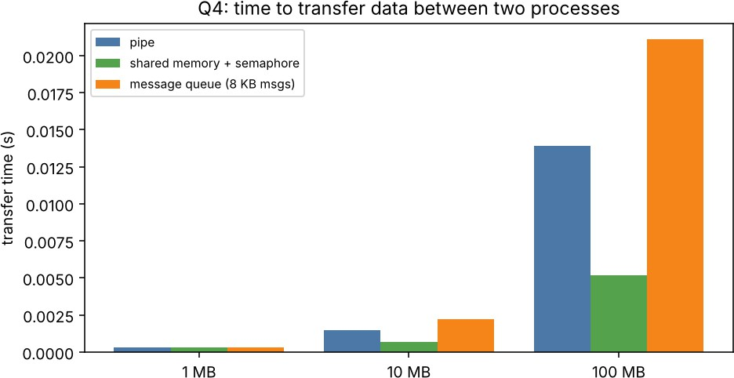
Figure 7 – Transfer time versus data size for each IPC method.
Transfer time grows linearly with data size for every method – O(n). The pipe and the message queue pay two copies per byte plus a system call per chunk; shared memory pays no copy, only a semaphore operation per 64 KB slot. At 100 MB shared memory was about 2.7× faster than the pipe (5.2 ms versus 13.9 ms) and about 4× faster than the message queue (21.1 ms; 8 KB messages mean 8× more system calls). At 1 MB all three are equal (0.3 ms), where the fixed cost of fork and setup dominates.

Alternative concept and justified choice

Method | Time for n readings | Synchronisation
Pipe | O(n); two kernel copies per reading; one write()/read() system call per reading | Built in (blocking)
Shared memory + semaphore | O(n) writes, zero kernel copies; two semaphore operations per hand-off (cheap when uncontended) | Programmer-supplied semaphores

Choice: for the weather station – a few integers per second – use the pipe: copying six integers costs nothing, and the kernel provides blocking, ordering and end-of-data without extra code, so there are fewer places for bugs. If the station later sends large arrays (images, thousands of samples per second) switch to shared memory with a ring buffer and semaphores, as measured above.

Q5 – Synchronisation: Critical Sections, Semaphores and Monitors (11 marks)
  - From principle to design
A solution to the critical-section problem must satisfy: mutual exclusion (only one process in the critical section), progress (only processes wanting to enter take part in the decision, and it cannot be postponed forever), and bounded waiting (a limit on how many times others may enter before a waiting process does).

Peterson's solution (two processes) Pseudocode
int flag[2] = {0, 0}; int turn;
/* process i, other process j = 1 - i */ flag[i] = 1; /* I want to enter */ turn = j; /* but you go first */ while (flag[j] && turn == j) ; /* wait */
/* critical section */ flag[i] = 0; /* exit */

    - Mutual exclusion: both processes are in the critical section only if flag[0] = flag[1] = 1 and the waiting condition is false for both; but turn has one value, so only one of them can pass.
    - Progress: if Pj is not interested, flag[j] = 0 and Pi enters immediately; the decision involves only the two contenders.
    - Bounded waiting: after Pj leaves, it sets flag[j] = 0; if it comes back it sets turn
= i, so Pi enters after at most one entry of Pj.
    - Why it may fail on modern processors: compilers and CPUs reorder independent instructions and use store buffers, so flag[i] = 1 and turn = j may become visible to the other processor in a different order, or the read of flag[j] may be satisfied before the store is visible. Both processes can then enter. Correct use needs memory barriers (fences) or atomic operations with sequential consistency.

Semaphores protecting the seat counter Pseudocode
semaphore seats_mutex = 1; /* binary semaphore */ int seats_left = 120;
book():
wait(seats_mutex);
if (seats_left > 0) { seats_left--; sell(); } signal(seats_mutex);
semaphore free_seats = 120; /* counting semaphore: counts the resource */

book(): wait(free_seats); sell(); cancel(): signal(free_seats);
/* blocks when the train is full */

A binary semaphore (value 0/1) gives mutual exclusion around the check-and-decrement, so two agents can never both see one seat left and sell it twice. A counting semaphore initialised to the number of seats makes a booking wait (or fail with try-wait) when no seat is free and wakes one waiting agent for each cancellation.

Classic problems solved with semaphores

Problem | Semaphores | Idea
Bounded buffer (producer–consumer) | empty = N, full = 0, mutex = 1 | Producer: wait(empty); wait(mutex); insert; signal(mutex); signal(full). Consumer: wait(full); wait(mutex); remove; signal(mutex); signal(empty). Section 5.3  implements it.
Readers–writers (readers preference) | rw_mutex = 1,  mutex = 1, read_count | First reader locks rw_mutex, last reader releases it; writers lock rw_mutex. Many readers or one writer. (Writers can starve – a writer-priority variant avoids it.)
Dining philosophers | chopstick[5] = 1 each, room = 4 | Philosopher: wait(room); wait(chopstick[i]); wait(chopstick[(i+1)%5]); eat; signal both; signal(room). At most 4 can sit, so at least one has both chopsticks – no deadlock (alternative: odd philosophers take the left chopstick first, even the right).

Monitor with condition variables Pseudocode
monitor Booking {
int seats = 120; condition seat_available; procedure book() {
while (seats == 0) wait(seat_available); // releases the monitor lock while waiting
seats--;
}
procedure cancel() { seats++; signal(seat_available); }
}

In a monitor only one process can be active inside at a time, so mutual exclusion is automatic and cannot be forgotten; the programmer only writes the waiting conditions. With semaphores, forgetting one wait() or signal(), or reversing their order, causes lost mutual exclusion or deadlock – the monitor removes that class of bug. (In C the equivalent is a pthread mutex plus pthread_cond_t.)
  - Implement: bounded buffer (Complete the Code, TODO 1 and TODO 2) Q5/bounded.c (compile: gcc -std=c11 -Wall -Wextra -pthread bounded.c; with
-DNP=4 for 4 producers + 4 consumers)
#define _POSIX_C_SOURCE 200809L #include <stdio.h>
#include <pthread.h> #include <semaphore.h> #include <sched.h>
#define SIZE 5
#define ITEMS 20 #ifndef NP
#define NP 1 /* number of producers = number of consumers (compile with
-DNP=4) */
#endif
/* -DNOMUTEX removes the mutex; -DYIELD adds sched_yield() inside the critical section (widens the race on 1 CPU) */
#ifdef NOMUTEX #define LOCK() #define UNLOCK() #else
#define LOCK() pthread_mutex_lock(&lock) #define UNLOCK() pthread_mutex_unlock(&lock) #endif
#ifdef YIELD
#define Y() sched_yield() #else
#define Y() #endif
int buffer[SIZE], in = 0, out = 0; sem_t empty, full;
pthread_mutex_t lock = PTHREAD_MUTEX_INITIALIZER; long consumed_sum = 0;
int consumed_count = 0;
void *producer(void *arg) { (void)arg;
for (int item = 1; item <= ITEMS; item++) {

/* TODO 1 - completed */ sem_wait(&empty); LOCK();
buffer[in] = item; Y();
in = (in + 1) % SIZE; UNLOCK();
sem_post(&full);
}
return NULL;
}
void *consumer(void *arg) { (void)arg;
for (int k = 0; k < ITEMS; k++) {
/* TODO 2 - completed */ sem_wait(&full); LOCK();
int item = buffer[out]; Y();
out = (out + 1) % SIZE; UNLOCK();
sem_post(&empty);
atomic_fetch_add(&consumed_sum, item, ATOMIC_RELAXED); /* atomic only so that the *sum* itself is not a second race */
atomic_fetch_add(&consumed_count, 1, ATOMIC_RELAXED);
}
return NULL;
}
int main(void) { sem_init(&empty, 0, SIZE);
sem_init(&full, 0, 0); pthread_t p[NP], c[NP];
for (int i = 0; i < NP; i++) { pthread_create(&p[i], NULL, producer, NULL); pthread_create(&c[i], NULL, consumer, NULL); }
for (int i = 0; i < NP; i++) { pthread_join(p[i], NULL); pthread_join(c[i], NULL); }
printf("items consumed: %d, sum = %ld (expected %d)\n", consumed_count, consumed_sum, NP * ITEMS * (ITEMS + 1) / 2);
sem_destroy(&empty); sem_destroy(&full); return 0;
}

Output – 1 producer, 1 consumer (expected: sum = 210)
items consumed: 20, sum = 210 (expected 210)

Note: TODO 2 adds the item to consumed_sum. With several consumers that addition itself would be a data race, so it is done with an atomic add; the TODO 1/TODO 2 logic (semaphores and mutex) is exactly as specified.

Test your design: 100 runs, 1 and 4 producers/consumers

Q5 – 100 runs of each build (a run is correct when count and sum match)
./bounded : 100 runs -> correct=100, wrong-or-hung=0
./bounded4 : 100 runs -> correct=100, wrong-or-hung=0
./bounded4_yield : 100 runs -> correct=100, wrong-or-hung=0
./bounded4_nomutex : 100 runs -> correct=100, wrong-or-hung=0
./bounded4_nomutex_yield : 100 runs -> correct=6, wrong-or-hung=94

Build | Runs correct (of 100) | Meaning
1 producer, 1 consumer, semaphores  + mutex | 100 | sum = 210 every time, 20 items consumed
4 producers, 4 consumers, semaphores + mutex | 100 | sum = 840, 80 items consumed exactly once
4+4 with sched_yield() inside the critical section, mutex kept | 100 | Mutual exclusion holds even when the scheduler interleaves aggressively
4+4, mutex removed (natural scheduling) | 100 | Correct only by luck: on a 1-CPU machine a thread is rarely preempted inside the two-instruction window
4+4, mutex removed, sched_yield() inside the window | 6 | 94 of 100 runs wrong or hung

Example of a failing run without the mutex (sum 847, expected 840)
items consumed: 80, sum = 847 (expected 840)

Evaluation: the semaphores empty and full only count free and used slots; they do not make the update of in/out and the buffer contents atomic. With several producers, two of them can both read the same value of in, write into the same slot (one item lost) and advance in once or twice (a slot is skipped and a consumer later reads a stale or overwritten item). Hence the sum and count are wrong, or – when the indices get out of step – the program hangs. With one producer and one

consumer the mutex is not strictly needed (each index has a single writer) but with several it is essential.

Deployment decision: one lock for the system, per train or per coach
Q5/booking_locks.c (16 trains × 4 coaches × 50 seats; 32 agents; the lock is held during a 100 µs simulated database write)
one global lock 0.556 s 23018 attempts/s sold=3141 (counter 3141) double-sold seats=0
one lock per train 0.059 s 216898 attempts/s sold=3141 (counter 3141) double-sold seats=0
one lock per coach double-sold seats=0
0.031 s
417677 attempts/s sold=3141 (counter 3141)

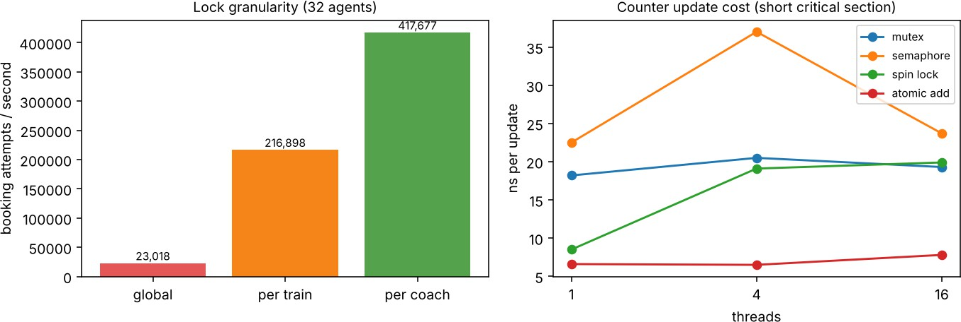
Figure 8 – Left: throughput by lock granularity. Right: cost of one counter update by method.

Design | Throughput (attempts/s) | Relative | Double-sold seats
One global lock | 23,018 | 1× | 0
One lock per train | 216,898 | 9.4× | 0
One lock per coach | 417,677 | 18.1× | 0

Decision: one lock per coach. It is 18× faster than the global lock and 1.9× faster than the per-train lock, and no seat was sold twice in any design (checked by counting every seat). The global lock serialises all trains although bookings on different trains never conflict – exactly the slow behaviour reported. A coach is the smallest unit that a single seat booking touches, so finer locking (per seat) would add memory and complexity for little gain. Caveats: a booking that spans several coaches must acquire the locks in a fixed order (e.g. by coach number) to avoid deadlock, and the measurements come from a 1-CPU machine, where the gain

comes from overlapping waiting inside the lock; on a multi-core machine the CPU-bound gain adds to it.

Alternative concept: atomic operations or spin lock instead of a semaphore/mutex
Q5/atomic_spin.c – 400,000 updates in total, split among 1, 4 or 16 threads
 | method threads ns per upd mutex 1 18.2 |  |  | ate CPU ti 0.007 | me (s) final 400000
 | mutex | 4 | 20.5 | 0.008 | 400000
 | mutex | 16 | 19.3 | 0.008 | 400000
 | semaphore | 1 | 22.5 | 0.009 | 400000
 | semaphore | 4 | 37.0 | 0.015 | 400000
 | semaphore | 16 | 23.7 | 0.009 | 400000
 | spin lock | 1 | 8.5 | 0.003 | 400000
 | spin lock | 4 | 19.1 | 0.008 | 400000
 | spin lock | 16 | 19.9 | 0.008 | 400000
 | atomic add | 1 | 6.6 | 0.003 | 400000
 | atomic add | 4 | 6.5 | 0.003 | 400000
 | atomic add | 16 | 7.8 | 0.003 | 400000

Q5/long_cs.c – long critical section (holder blocks 200 µs), 4 threads × 200 updates
mutex (sleeps)
wall 0.242 s CPU used 0.026 s count=800
spin lock (busy-waits) wall 0.274 s CPU used 0.215 s count=800

Method | Time per update (1 / 4 / 16 threads) | Comment
Mutex | 18.2 / 20.5 / 19.3 ns | Sleeps when contended; safe for any length of critical section
Semaphore | 22.5 / 37.0 / 23.7 ns | Slightly slower; general (counting) and usable across processes
Spin lock | 8.5 / 19.1 / 19.9 ns | Fast when  uncontended; busy-waits when the lock is held
Atomic add (C11 atomic_fetch_add) | 6.6 / 6.5 / 7.8 ns | Fastest and flat: one hardware instruction, no lock, no waiting

For a single counter, atomic_fetch_add is best: ≈ 3× faster than a mutex and independent of the number of threads (O(1) per update, no blocking). A spin lock is acceptable only for very short critical sections with a core per thread. With a long critical section the holder is blocked while the others spin: the spin lock used 0.215 s of CPU for 0.274 s of wall time, against 0.026 s of CPU for the mutex – about 8× more CPU wasted for no gain. A long critical section (such as the seat reservation with its database write) needs a blocking lock (mutex or semaphore); a spin lock or atomic is suited to updating a counter, but cannot protect a multi-step check-then-sell that must stay consistent across several variables.

Q6 – Deadlock Handling and the Banker's Algorithm (13 marks)
- Characterise deadlock (2 marks)
The four necessary conditions (all must hold together):
  - **Mutual exclusion** – a GPU, licence or storage channel is used by one job at a time.
  - **Hold and wait** – a job holds some resources (e.g. a GPU) while waiting for others (e.g. a licence).
  - **No preemption** – a running job's resources cannot be taken away; they are released only voluntarily.
  - **Circular wait** – there is a cycle J1 → J3 → J2 → J1 of jobs each waiting for a resource held by the next.
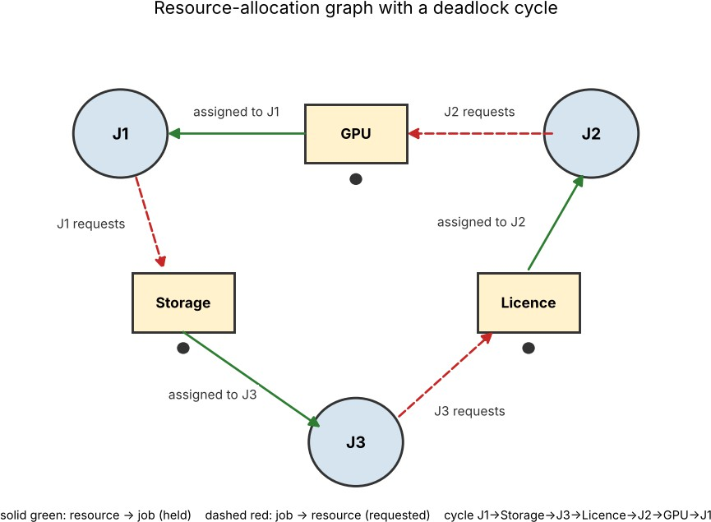
Figure 9 – Resource-allocation graph of the cluster: J1 holds the GPU and wants Storage; J3 holds Storage and wants the Licence; J2 holds the Licence and wants the GPU. Every resource has a single instance, so the cycle means deadlock.

Condition | Where it appears in the graph
Mutual exclusion | Each resource box has a single instance (one dot) and one outgoing assignment edge
Hold and wait | Every job has both a solid edge (holds) and a dashed edge (requests)
No preemption | No edge can be removed by the system; only the holder removes it
Circular wait | The closed cycle J1 → Storage → J3 → Licence → J2  → GPU → J1

Alternative concept (detection and recovery) and complexity: instead of checking every request, the system lets requests proceed and runs a detection algorithm (a wait-for-graph cycle search, O(m × n²) for multiple-instance resources, or O(n²) for single instances) every few minutes. Per request the cost is zero (no check), against O(m × n²) for every Banker's check. When a deadlock is found one job is aborted (or resources are preempted), which wastes all the work done so far unless the jobs checkpoint; detection also lets the cluster stay frozen up to the detection interval.

Compare the strategies (3 marks)

Strategy | How it works | Cost for the cluster | Verdict
Prevention | Deny one necessary condition: request all resources at once (no hold-and-wait), or order resource types and request in that order (no circular wait); allow preemption of storage | Low run-time cost; but low utilisation (resources reserved early), and  GPUs/licences cannot be preempted | Good for ordering rules, expensive in utilisation
Avoidance (Banker's) | Grant a request only if the resulting state is safe; needs each job's maximum demand in advance | O(m × n²) per request (≈ 0.7 ms for 1,000 jobs, Section E); needs declared maxima; may delay requests | Strong guarantee; feasible because jobs declare resources at submission
Detection and recovery | Allow deadlock; run a detector periodically; abort or preempt a job | No per-request cost; cluster frozen until the next run; work lost on abort | Acceptable if  jobs are  checkpointed and deadlocks are rare
Ignore (ostrich) | Pretend deadlock cannot happen; administrator reboots | Zero cost, but the whole cluster stops – exactly the current problem | Not acceptable here

Apply the Banker's algorithm (4 marks)
Implementation of the safety algorithm (is_safe) and the resource-request algorithm (request) – the Complete-the-Code program, TODO 1 completed:

Q6/banker.c #include <stdio.h> #include <string.h>
#define P 5
#define R 3
int avail[R] = {3, 3, 2};
int maxm[P][R] = {{7, 5, 3}, {3, 2, 2}, {9, 0, 2}, {2, 2, 2}, {4, 3, 3}};
int alloc[P][R] = {{0, 1, 0}, {2, 0, 0}, {3, 0, 2}, {2, 1, 1}, {0, 0, 2}};
/* Returns 1 if the state is safe and stores a safe sequence in seq. */ int is_safe(int seq[P]) {
int work[R], finish[P] = {0}, count = 0; memcpy(work, avail, sizeof work); while (count < P) {
int found = 0;
for (int p = 0; p < P; p++) { if (finish[p]) continue;
/* TODO 1 - completed */ int ok = 1;
for (int r = 0; r < R; r++)
if (maxm[p][r] - alloc[p][r] > work[r]) { ok = 0; break; } if (ok) {
for (int r = 0; r < R; r++) work[r] += alloc[p][r]; finish[p] = 1;
seq[count++] = p; found = 1;
}
}
if (!found) return 0;
}
return 1;
}
void request(int p, const int req[R]) { for (int r = 0; r < R; r++)
if (req[r] > maxm[p][r] - alloc[p][r] || req[r] > avail[r]) { printf("P%d request: must wait (not available)\n", p); return;
}
for (int r = 0; r < R; r++) { avail[r] -= req[r]; alloc[p][r] += req[r]; } int seq[P];
if (is_safe(seq)) {
printf("P%d request: granted, safe sequence", p); for (int i = 0; i < P; i++) printf(" P%d", seq[i]); printf("\n");
} else {

for (int r = 0; r < R; r++) { avail[r] += req[r]; alloc[p][r] -= req[r]; } printf("P%d request: denied (unsafe)\n", p);
}
}
int main(void) { int seq[P];
if (is_safe(seq)) { printf("initial state safe:");
for (int i = 0; i < P; i++) printf(" P%d", seq[i]); printf("\n");
}
request(1, (int[R]){1, 0, 2});
request(4, (int[R]){3, 3, 0});
request(0, (int[R]){0, 2, 0});
return 0;
}

Output – identical to the expected output
initial state safe: P1 P3 P4 P0 P2
P1 request: granted, safe sequence P1 P3 P4 P0 P2 P4 request: must wait (not available)
P0 request: denied (unsafe)

Hand calculation: need matrix and safe sequence
Need = Max − Allocation: P0 (7,4,3), P1 (1,2,2), P2 (6,0,0), P3 (0,1,1), P4 (4,3,1).
Available = (3,3,2).

Step | Work before | Process chosen (Need ≤ Work) | Work after (+ Allocation)
1 | (3,3,2) | P1 (1,2,2) | (5,3,2)
2 | (5,3,2) | P3 (0,1,1) [P2 needs 6 > 5] | (7,4,3)
3 | (7,4,3) | P4 (4,3,1) | (7,4,5)
4 | (7,4,5) | P0 (7,4,3) | (7,5,5)
5 | (7,5,5) | P2 (6,0,0) | (10,5,7)

Safe sequence: P1, P3, P4, P0, P2 – the state is safe.

Request decisions
- P1 requests (1,0,2): (1,0,2) ≤ Need P1 (1,2,2) and ≤ Available (3,3,2). Pretend to allocate: Available (2,3,0), Allocation P1 (3,0,2), Need P1 (0,2,0). The safety algorithm finds P1, P3, P4, P0, P2 → granted.

- P4 requests (3,3,0): within its need (4,3,1) but (3,3,0) is not ≤ Available (2,3,0) (3 > 2 for resource A) → must wait.
- P0 requests (0,2,0): (0,2,0) ≤ Need P0 (7,4,3) and ≤ Available (2,3,0). Pretend to allocate → unsafe, denied (proof below).

Why P0's request for (0,2,0) leads to an unsafe state (by hand)
After the pretend allocation: Available = (2,1,0); Allocation P0 = (0,3,0); Need: P0 (7,2,3), P1 (0,2,0), P2 (6,0,0), P3 (0,1,1), P4 (4,3,1). Check whether any process can finish with Work = (2,1,0):

Process | Need | Need ≤ Work (2,1,0)? | Reason
P0 | (7,2,3) | No | 7 > 2 and 3 > 0
P1 | (0,2,0) | No | 2 > 1 (resource B)
P2 | (6,0,0) | No | 6 > 2
P3 | (0,1,1) | No | 1 > 0 (resource C)
P4 | (4,3,1) | No | 4 > 2

No process can complete, so no safe sequence exists: the state is unsafe (a deadlock becomes possible), and the request is denied and rolled back. Note that the request was available at that moment – the Banker's algorithm denies it only because granting it would leave the system unable to guarantee completion.

Predict before implementing (1 mark)
Prediction: the outer while-loop runs at most n times (each pass that does not fail finishes at least one process), each pass scans n processes, and each scan compares up to m resources. The worst-case time is therefore T(n, m) = c · m · n² = O(m × n²); the space is O(n × m). Testable consequences: (a) multiplying n by 10 multiplies the worst-case time by about 100; (b) multiplying m by k multiplies it by about k;
(c) in the average case, when most processes can finish in the first pass, the time is closer to O(m × n).

Measure (1 mark)
Q6/bench_banker.c (gcc -O2; worst case: processes can finish only in the order n−1 … 0 while the scan runs 0 … n−1)
worst case, m=3 n time (us)
10 0.19
ratio
- safe=1
100 9.21 safe=1
(x49 vs previous n; n^2 predicts x100)

1000
712.74
safe=1
(x77 vs previous n; n^2 predicts x100)
average (random, plentiful resources), m=3
10 0.08 us safe=1
100 0.47 us safe=1
1000 4.21 us safe=1
worst case, n=1000, varying m m= 3 716.87 us
m=12 823.26 us
m=48 873.36 us

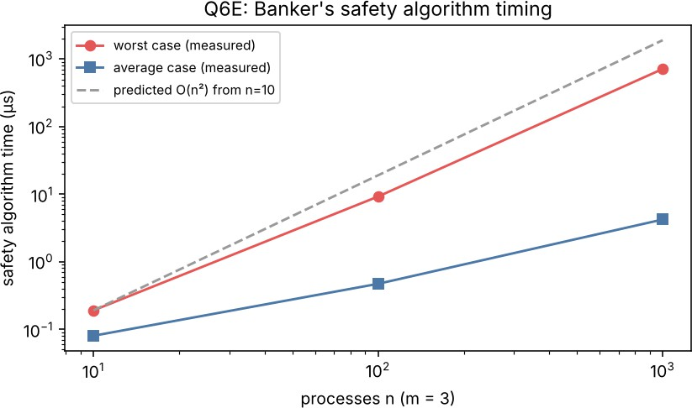
Figure 10 – Measured safety-algorithm time against the O(n²) prediction (log–log).

n (m = 3) | Worst-case time | Growth vs previous n | Predicted growth
10 | 0.19 µs | – | –
100 | 9.21 µs | × 49 | × 100
1,000 | 712.7 µs | × 77 | × 100

Comparison: the measured growth confirms the quadratic trend (the log–log slope is close to 2; the growth factors rise from ×49 towards ×100 as the fixed overheads become small compared with the n² term). The average case grows only ×6 and ×9 per decade, i.e. close to O(n), as predicted in (c). The prediction (b) was only partly confirmed: increasing m from 3 to 48 raised the time from 717 µs to 873 µs, not 16×, because in this test the inner comparison stops at the first resource that fails, so extra resource types are rarely examined; for states where every resource type must be compared the m-dependence would be linear. Even for 1,000 jobs the check takes under a millisecond.

Defend the final design (2 marks)
Recommendation: use the Banker's algorithm (deadlock avoidance) as the admission control of the cluster scheduler, combined with a lock/resource ordering rule and a time-out/detection mechanism as a safety net.
- Cost is acceptable: measured worst case 0.7 ms per safety check for 1,000 jobs and 3 resource types, against jobs lasting minutes to hours; the check runs only on resource requests, not continuously.
- Maximum demands can be known: research jobs are submitted through a batch system that already asks for GPUs, licences and storage in the job script, so the maximum claim exists in advance. This is the main requirement of the Banker's algorithm and is realistic here.
- Compared with the alternatives: ignoring deadlock is what causes the present cluster stops; prevention by requesting everything at once wastes expensive GPUs and licences while a job is still reading input; detection and recovery loses hours of simulation work on every abort.
- Limitations to accept: claims must not be understated (a job exceeding its declared maximum must be killed), the number of resources is fixed, and overstated claims lower utilisation because requests are delayed even when no deadlock would occur. Hence a safety net (time-outs, checkpointing and the periodic detector) is kept for jobs that fall outside the model.

Appendix A – README.md (for the GitHub repository)
README.md
# CSA04-<RegisterNumber>-Assignment2
Name: <your name> Register number: <your register number> ## Environment
- Compiler: gcc 13.3.0 (Ubuntu 13.3.0-6ubuntu2~24.04.1)
- OS: Ubuntu 24.04.5 LTS (1 virtual CPU)
- Python 3 with matplotlib (only for Q2 charts and the figures)
## Build and run (one folder per task)
Default compile command: gcc -std=c11 -Wall -Wextra -pthread <file>.c -o
<name>
| Task | Folder | Compile | Run |
| | | | |
| Q1 | Q1 | gcc -std=c11 -Wall -Wextra -pthread fork_demo.c -o fork_demo ; gcc - pthread bench_proc_vs_thread.c -o bench ; gcc -pthread memtest.c -o memtest |
./fork_demo ; ./bench ; ./memtest |
| Q2 | Q2 | gcc -std=c11 -Wall -Wextra rr.c -o rr ; gcc -std=c11 rr_study.c -o rr_study | ./rr ; ./rr_study 1 (3, 5, 20) ; python3 sched.py |
| Q3 | Q3 | gcc -std=c11 -Wall -Wextra -pthread cameras.c -o cameras (same for race.c, cameras_proc.c) | ./cameras ; ./race ; ./cameras_proc |
| Q4 | Q4 | gcc -std=c11 -Wall -Wextra pipe_analyser.c -o pipe_analyser ; gcc - DNO_CLOSE ... -o pipe_noclose ; gcc -std=gnu11 -pthread shm_analyser.c ; gcc
-std=gnu11 -O2 -pthread bench_ipc.c -o bench_ipc -lrt | ./pipe_analyser ; timeout 3 ./pipe_noclose ; ./shm_analyser ; ./bench_ipc |
| Q5 | Q5 | gcc -std=c11 -Wall -Wextra -pthread bounded.c (add -DNP=4, - DNOMUTEX, -DYIELD) ; gcc -std=gnu11 -O2 -pthread booking_locks.c / atomic_spin.c / long_cs.c | ./bounded ; ./booking_locks ; ./atomic_spin ; ./long_cs
|
| Q6 | Q6 | gcc -std=c11 -Wall -Wextra banker.c -o banker ; gcc -std=gnu11 -O2 bench_banker.c -o bench_banker | ./banker ; ./bench_banker |
## Results (short note per task)
- Q1: fork() demo shows S (waiting) and Z (zombie) states in ps and /proc; a process costs about 879 us to create versus 12 us for a thread; decision: fixed pool of worker processes serving sessions with threads.
- Q2: Round Robin output matches the expected output (average TAT 20.00, WT 13.50); quantum study 1/3/5/20; recommendation: multilevel feedback queue with ageing.
- Q3: 64 cameras; speed-up flattens near 4.6x because the CPU has 1 core; unprotected counter loses updates.
- Q4: pipe and shared-memory versions both print "6 readings, average 35.5, max 41"; removing close(fd[1]) makes the child wait forever; shared memory is about
2.7x faster than a pipe for 100 MB.

- Q5: bounded buffer gives sum = 210 in 100 of 100 runs (also 4+4 threads); removing the mutex breaks it; per-coach locking is 18x faster than one global lock.
- Q6: Banker's output matches the expected output; safety check measured for 10/100/1000 processes (about O(m n^2) in the worst case).
## Commit plan (at least one commit per task)
git add Q1 && git commit -m "Q1: fork demo, benchmarks, design decision" (repeat for Q2 ... Q6, then the report).

Appendix B – All C source files
Q1/fork_demo.c
#define _POSIX_C_SOURCE 200809L #include <stdio.h>
#include <stdlib.h> #include <unistd.h> #include <sys/wait.h>
/* Q1: create child "student sessions" with fork(), observe with ps and /proc */ int main(void) {
const int N = 4; pid_t kids[4];
for (int i = 0; i < N; i++) { pid_t pid = fork();
if (pid == 0) { /* child = one student session */
if (i == 3) _exit(0); /* exits at once, parent has not reaped it -> zombie (terminated) */
sleep(3); /* others sleep -> WAITING state */
_exit(0);
}
kids[i] = pid;
}
sleep(1);
printf("parent pid=%d created children:", getpid()); for (int i = 0; i < N; i++) printf(" %d", kids[i]);
printf("\n\n--- ps -o pid,ppid,stat,vsz,rss,comm (parent + children) ---\n"); char cmd[256];
snprintf(cmd, sizeof cmd, "ps -o pid,ppid,stat,vsz,rss,comm --ppid %d --pid
%d", getpid(), getpid()); fflush(stdout); system(cmd);
printf("\n--- /proc/%d/status of child 0 (PCB fields) ---\n", kids[0]); snprintf(cmd, sizeof cmd, "grep -E
'Name|State|^Pid|PPid|VmSize|VmRSS|voluntary_ctxt|nonvoluntary_ctxt'
/proc/%d/status", kids[0]); fflush(stdout); system(cmd);
for (int i = 0; i < N; i++) waitpid(kids[i], NULL, 0); printf("\nall children reaped (state: terminated)\n"); return 0;
}

Q1/bench_proc_vs_thread.c
#define _GNU_SOURCE #include <stdio.h> #include <stdlib.h> #include <unistd.h> #include <pthread.h>

#include <sys/wait.h> #include <time.h> #include <sched.h>
/* Q1 evaluation: creation cost of 2000 processes vs 2000 threads, and context-switch cost */
static double now(void){struct timespec t;clock_gettime(CLOCK_MONOTONIC,&t);return t.tv_sec+t.tv_nsec*1e-9;} static char *big;
static void *tfn(void *a){(void)a; return NULL;} int main(void){
int N=2000;
big=malloc(64<<20); for(long i=0;i<(64<<20);i+=4096) big[i]=1; /* 64 MB resident in parent */
double t=now();
for(int i=0;i<N;i++){pid_t p=fork(); if(p==0)_exit(0); waitpid(p,NULL,0);} double tp=(now()-t)/N*1e6;
t=now(); pthread_t th; for(int
i=0;i<N;i++){pthread_create(&th,NULL,tfn,NULL);pthread_join(th,NULL);} double tt=(now()-t)/N*1e6;
int a[2],b[2]; if(pipe(a)||pipe(b)) return 1;
cpu_set_t cs;CPU_ZERO(&cs);CPU_SET(0,&cs);sched_setaffinity(0,sizeof cs,&cs);
int R=100000; char c='x'; pid_t p=fork(); if(p==0){for(int
i=0;i<R;i++){if(read(a[0],&c,1)<0)break;if(write(b[1],&c,1)<0)break;}_exit(0);} t=now(); for(int
i=0;i<R;i++){if(write(a[1],&c,1)<0)break;if(read(b[0],&c,1)<0)break;} double tc=(now()-t)/(2.0*R)*1e6;
waitpid(p,NULL,0);
printf("fork+wait (parent holds 64MB): %.1f us per process\n",tp); printf("pthread_create+join : %.1f us per thread\n",tt); printf("process context switch (pipe ping-pong, 1 CPU): %.2f us\n",tc); return 0;
}

Q1/memtest.c
#define _GNU_SOURCE #include <stdio.h> #include <unistd.h> #include <pthread.h> #include <sys/wait.h>
static void *f(void*a){(void)a;sleep(2);return 0;}
static long kb(const char*k){FILE*fp=fopen("/proc/meminfo","r");char l[128];long

v=0;while(fgets(l,128,fp)){if(! builtin_strncmp(l,k, builtin_strlen(k))){sscanf( l+ builtin_strlen(k)+1,"%ld",&v);}}fclose(fp);return v;}
int main(void){
int N=1000; long b=kb("MemAvailable");
pid_t p[1000]; for(int i=0;i<N;i++){p[i]=fork(); if(!p[i]){sleep(2);_exit(0);}} usleep(500000); long a=kb("MemAvailable");
printf("1000 forked processes : %ld KB extra (%.0f KB each)\n",b-a,(b-a)/1000.0);
for(int i=0;i<N;i++)waitpid(p[i],0,0); usleep(200000); b=kb("MemAvailable");
pthread_t t[1000]; for(int i=0;i<N;i++)pthread_create(&t[i],0,f,0); usleep(500000); a=kb("MemAvailable");
printf("1000 threads : %ld KB extra (%.0f KB each)\n",b-a,(b-a)/1000.0); for(int i=0;i<N;i++)pthread_join(t[i],0);
return 0;}

Q2/rr.c
#include <stdio.h>
#define N 4
int main(void) {
const char *name[N] = {"P1", "P2", "P3", "P4"}; int arrival[N] = {0, 1, 2, 3};
int burst[N] = {8, 4, 9, 5}; int quantum = 3;
int left[N], finish[N], queue[64], head = 0, tail = 0, added[N] = {0}; for (int i = 0; i < N; i++) left[i] = burst[i];
int time = 0, done = 0; queue[tail++] = 0;
added[0] = 1; printf("Gantt:"); while (done < N) {
int p = queue[head++];
/* TODO 1 - completed */
int run = left[p] < quantum ? left[p] : quantum; printf(" %s(%d-%d)", name[p], time, time + run); time += run;
left[p] -= run;
for (int i = 0; i < N; i++)
if (!added[i] && arrival[i] <= time) { queue[tail++] = i; added[i] = 1; } if (left[p] > 0) queue[tail++] = p;
else { finish[p] = time; done++; }
}
double tw = 0, tt = 0; printf("\nProcess TAT WT\n");

for (int i = 0; i < N; i++) {
int tat = finish[i] - arrival[i], wt = tat - burst[i]; tt += tat;
tw += wt;
printf("%-7s %4d %3d\n", name[i], tat, wt);
}
printf("Average TAT = %.2f, average WT = %.2f\n", tt / N, tw / N); return 0;
}

Q2/rr_study.c
#include <stdio.h> #define N 4
#include <stdlib.h>
int main(int argc, char **argv) {
const char *name[N] = {"P1", "P2", "P3", "P4"}; int arrival[N] = {0, 1, 2, 3};
int burst[N] = {8, 4, 9, 5};
int quantum = argc > 1 ? atoi(argv[1]) : 3; int slices = 0;
int left[N], finish[N], queue[256], head = 0, tail = 0, added[N] = {0}; for (int i = 0; i < N; i++) left[i] = burst[i];
int time = 0, done = 0; queue[tail++] = 0;
added[0] = 1; printf("Gantt:"); while (done < N) {
int p = queue[head++];
/* TODO 1 - completed */
int run = left[p] < quantum ? left[p] : quantum; printf(" %s(%d-%d)", name[p], time, time + run); time += run; slices++;
left[p] -= run;
for (int i = 0; i < N; i++)
if (!added[i] && arrival[i] <= time) { queue[tail++] = i; added[i] = 1; } if (left[p] > 0) queue[tail++] = p;
else { finish[p] = time; done++; }
}
double tw = 0, tt = 0; printf("\nProcess TAT WT\n"); for (int i = 0; i < N; i++) {
int tat = finish[i] - arrival[i], wt = tat - burst[i]; tt += tat;
tw += wt;
printf("%-7s %4d %3d\n", name[i], tat, wt);

}
printf("context switches = %d\n", slices - 1);
printf("Average TAT = %.2f, average WT = %.2f\n", tt / N, tw / N); return 0;
}

Q3/cameras.c
#define _DEFAULT_SOURCE #include <stdio.h>
#include <stdlib.h> #include <pthread.h> #include <time.h> #include <unistd.h>
/* Q3: 64 cameras, each frame = I/O wait (grab frame from network) + CPU work (plate recognition).
Modes: serial, one thread per camera, pool of K threads taking cameras from a shared counter. */
#define CAMS 64
#define IO_US 20000 /* 20 ms waiting for the camera frame */ #define WORK 2000000L /* CPU work per frame */
static int next_cam = 0;
static pthread_mutex_t m = PTHREAD_MUTEX_INITIALIZER; static volatile long sink;
static double now(void){struct timespec t;clock_gettime(CLOCK_MONOTONIC,&t);return t.tv_sec+t.tv_nsec*1e-9;} static void process_frame(int cam){
usleep(IO_US); /* blocked: CPU is free for other threads */ long x = cam; for(long i=0;i<WORK;i++) x = x*1103515245L + 12345; sink =
x; /* plate recognition */
}
static void *pool_worker(void *a){ (void)a;
for(;;){ pthread_mutex_lock(&m); int c = next_cam < CAMS ? next_cam++ : - 1; pthread_mutex_unlock(&m);
if(c<0) break; process_frame(c); }
return NULL;
}
static void *one_cam(void *a){ process_frame((int)(long)a); return NULL; } int main(void){
double t0=now(); for(int c=0;c<CAMS;c++) process_frame(c); double ts=now()-t0;
printf("serial (1 thread) : %.3f s speed-up 1.00\n",ts); pthread_t th[CAMS];
t0=now(); for(long c=0;c<CAMS;c++) pthread_create(&th[c],NULL,one_cam,(void*)c);
for(int c=0;c<CAMS;c++) pthread_join(th[c],NULL);

double t=now()-t0; printf("one thread per camera
%.2f\n",t,ts/t);
int pools[]={4,8,16}; for(int k=0;k<3;k++){
: %.3f s
speed-up
next_cam=0; int K=pools[k]; t0=now();
for(int i=0;i<K;i++) pthread_create(&th[i],NULL,pool_worker,NULL); for(int i=0;i<K;i++) pthread_join(th[i],NULL);
t=now()-t0; printf("pool of %2d threads : %.3f s speed-up %.2f\n",K,t,ts/t);
}
return 0;
}

Q3/cameras_proc.c
#define _DEFAULT_SOURCE #include <stdio.h>
#include <stdlib.h> #include <unistd.h> #include <time.h> #include <sys/wait.h>
/* Q3 alternative: K worker PROCESSES, cameras split statically; each reports its result count over a pipe */
#define CAMS 64
#define IO_US 20000 #define WORK 2000000L static volatile long sink;
static double now(void){struct timespec t;clock_gettime(CLOCK_MONOTONIC,&t);return t.tv_sec+t.tv_nsec*1e-9;}
int main(void){
int Ks[]={4,8,16};
for(int k=0;k<3;k++){
int K=Ks[k], fd[2]; if(pipe(fd)) return 1; double t0=now(); for(int i=0;i<K;i++){
if(fork()==0){ int done=0;
for(int c=i;c<CAMS;c+=K){ usleep(IO_US); long x=c; for(long j=0;j<WORK;j++) x=x*1103515245L+12345; sink=x; done++; }
if(write(fd[1],&done,sizeof done)<0) _exit(1);
_exit(0); } }
close(fd[1]); int total=0,part; while(read(fd[0],&part,sizeof part)>0) total+=part;
while(wait(NULL)>0) {} double t=now()-t0; close(fd[0]);
printf("%2d processes: %.3f s frames=%d (results combined via pipe)\n",K,t,total);
}
return 0; }

Q3/race.c
#define _POSIX_C_SOURCE 200809L #include <stdio.h>
#include <sched.h> #include <pthread.h> #include <stdatomic.h>
/* Q3: threads update a shared counter without protection, with a mutex, and atomically.
The load..store window is widened with sched_yield() every 100 updates so the race shows up
reliably even on a 1-CPU machine (where natural preemption inside the window is rare). */
#define PER 200000
static long unsafe_cnt = 0, mutex_cnt = 0; static atomic_long atomic_cnt = 0; static pthread_mutex_t m = PTHREAD_MUTEX_INITIALIZER;
static void *w(void *a){ (void)a; for(int i=0;i<PER;i++){
long t = unsafe_cnt; if(i%100==0) sched_yield(); unsafe_cnt = t+1; /* unprotected read-modify-write */
pthread_mutex_lock(&m); t = mutex_cnt; if(i%100==0) sched_yield(); mutex_cnt = t+1; pthread_mutex_unlock(&m);
atomic_fetch_add(&atomic_cnt,1);
}
return NULL; } int main(void){
pthread_t t[4]; for(int i=0;i<4;i++) pthread_create(&t[i],NULL,w,NULL); for(int i=0;i<4;i++) pthread_join(t[i],NULL);
printf("expected : %d\nunprotected: %ld (lost %ld updates)\nmutex :
%ld\natomic : %ld\n",4*PER,unsafe_cnt,4L*PER-unsafe_cnt,mutex_cnt,(long)atomic_cnt);
return 0; }

Q4/pipe_analyser.c
#define _POSIX_C_SOURCE 200809L #include <stdio.h>
#include <unistd.h> #include <sys/wait.h>
/* The parent (sensor reader) sends readings to the child (analyser) through a pipe.
*/
int main(void) { int fd[2];
if (pipe(fd) == -1) { perror("pipe"); return 1; } pid_t pid = fork();
if (pid == 0) {
close(fd[1]); /* child only reads */ int r, count = 0, sum = 0, max = 0;

/* TODO 1 - completed */
while (read(fd[0], &r, sizeof r) == (ssize_t)sizeof r) { count++;
sum += r;
if (r > max) max = r;
}
printf("analyser: %d readings, average %.1f, max %d\n", count, count ? (double)sum / count : 0.0, max);
close(fd[0]); fflush(stdout);
_exit(0);
}
close(fd[0]); /* parent only writes */ int readings[] = {31, 33, 36, 34, 41, 38};
for (int i = 0; i < 6; i++)
if (write(fd[1], &readings[i], sizeof readings[i]) < 0) perror("write"); #ifndef NO_CLOSE
close(fd[1]); /* signals end of data to the child */ #endif
waitpid(pid, NULL, 0); printf("reader: done\n"); return 0;
}

Q4/shm_analyser.c #define _GNU_SOURCE #include <stdio.h>
#include <unistd.h> #include <semaphore.h> #include <sys/mman.h> #include <sys/wait.h>
/* Q4 alternative: same weather readings through shared memory + two semaphores (one-slot buffer) */
typedef struct { sem_t empty, full; int value; int eof; } box_t; int main(void){
box_t *b = mmap(NULL, sizeof *b, PROT_READ|PROT_WRITE, MAP_SHARED|MAP_ANONYMOUS, -1, 0);
sem_init(&b->empty, 1, 1); sem_init(&b->full, 1, 0); b->eof = 0; pid_t pid = fork();
if (pid == 0) {
int count = 0, sum = 0, max = 0; for (;;) {
sem_wait(&b->full);
if (b->eof) break; /* end-of-data flag replaces pipe close() */ int r = b->value; count++; sum += r; if (r > max) max = r;
sem_post(&b->empty);
}

printf("analyser: %d readings, average %.1f, max %d\n", count, count ? (double)sum/count : 0.0, max);
fflush(stdout);
_exit(0);
}
int readings[] = {31, 33, 36, 34, 41, 38};
for (int i = 0; i < 6; i++) { sem_wait(&b->empty); b->value = readings[i]; sem_post(&b->full); }
sem_wait(&b->empty); b->eof = 1; sem_post(&b->full); waitpid(pid, NULL, 0);
printf("reader: done\n"); return 0;
}

Q4/bench_ipc.c
#define _GNU_SOURCE #include <stdio.h> #include <stdlib.h> #include <string.h> #include <unistd.h> #include <fcntl.h> #include <semaphore.h> #include <sys/mman.h> #include <sys/wait.h> #include <mqueue.h> #include <time.h>
/* Q4: time to move 1, 10, 100 MB from producer (sensor) to consumer (analyser).
(a) pipe (b) shared memory ring + POSIX semaphores (c) POSIX message queue (8 KB messages) */
#define CHUNK 65536
#define SLOTS 8
static double now(void){struct timespec t;clock_gettime(CLOCK_MONOTONIC,&t);return t.tv_sec+t.tv_nsec*1e-9;} typedef struct { sem_t empty, full; int len[SLOTS]; char data[SLOTS][CHUNK];
} ring_t;
static double bench_pipe(size_t total){
int fd[2]; if(pipe(fd)) exit(1); static char buf[CHUNK]; double t0=now(); pid_t p=fork();
if(p==0){ close(fd[1]); size_t got=0; ssize_t n; static char rb[CHUNK]; unsigned long s=0;
while((n=read(fd[0],rb,CHUNK))>0){ got+=n; for(ssize_t i=0;i<n;i+=64) s+=rb[i]; } _exit(got==total?0:1); }
close(fd[0]); memset(buf,7,CHUNK); for(size_t sent=0;sent<total;sent+=CHUNK) if(write(fd[1],buf,CHUNK)<0) exit(1);
close(fd[1]); int st; waitpid(p,&st,0); return now()-t0; }

static double bench_shm(size_t total){
ring_t *r = mmap(NULL,sizeof
*r,PROT_READ|PROT_WRITE,MAP_SHARED|MAP_ANONYMOUS,-1,0);
sem_init(&r->empty,1,SLOTS); sem_init(&r->full,1,0); double t0=now(); pid_t p=fork();
if(p==0){ size_t got=0; int out=0; unsigned long s=0; while(got<total){ sem_wait(&r->full);
for(int i=0;i<r->len[out];i+=64) s+=r->data[out][i]; /* read in place: no
copy */
got+=r->len[out]; out=(out+1)%SLOTS; sem_post(&r->empty);}
_exit(0);}
int in=0; for(size_t sent=0;sent<total;sent+=CHUNK){ sem_wait(&r->empty); memset(r->data[in],7,CHUNK); r->len[in]=CHUNK; /* produce
directly in shared memory */ in=(in+1)%SLOTS; sem_post(&r->full); }
int st; waitpid(p,&st,0); double t=now()-t0; munmap(r,sizeof *r); return t; }
static double bench_mq(size_t total){
struct mq_attr a={0,10,8192,0}; mq_unlink("/benchq"); mqd_t q=mq_open("/benchq",O_CREAT|O_RDWR,0600,&a);
if(q==(mqd_t)-1) return -1; static char buf[8192]; memset(buf,7,sizeof buf); double t0=now(); pid_t p=fork();
if(p==0){ size_t got=0; static char rb[8192]; while(got<total){ ssize_t n=mq_receive(q,rb,sizeof rb,NULL); if(n<0) _exit(1); got+=n; } _exit(0);}
for(size_t sent=0;sent<total;sent+=8192) if(mq_send(q,buf,8192,0)<0) exit(1); int st; waitpid(p,&st,0); double t=now()-t0; mq_close(q);
mq_unlink("/benchq"); return t; }
int main(void){
size_t mb[]={1,10,100};
printf("%-6s %12s %18s %22s\n","size","pipe (s)","shared mem+sem (s)","message queue 8K (s)");
for(int i=0;i<3;i++){ size_t n=mb[i]<<20; double bp=1e9,bs=1e9,bm=1e9; for(int r=0;r<5;r++){ double x=bench_pipe(n); if(x<bp)bp=x;
x=bench_shm(n); if(x<bs)bs=x; x=bench_mq(n); if(x>0&&x<bm)bm=x; } printf("%3zu MB %12.4f %18.4f %22.4f\n",mb[i],bp,bs,bm); }
return 0; }

Q5/bounded.c
#define _POSIX_C_SOURCE 200809L #include <stdio.h>
#include <pthread.h> #include <semaphore.h> #include <sched.h>
#define SIZE 5
#define ITEMS 20

#ifndef NP
#define NP 1 /* number of producers = number of consumers (compile with
-DNP=4) */
#endif
/* -DNOMUTEX removes the mutex; -DYIELD adds sched_yield() inside the critical section (widens the race on 1 CPU) */
#ifdef NOMUTEX #define LOCK() #define UNLOCK() #else
#define LOCK() pthread_mutex_lock(&lock) #define UNLOCK() pthread_mutex_unlock(&lock) #endif
#ifdef YIELD
#define Y() sched_yield() #else
#define Y() #endif
int buffer[SIZE], in = 0, out = 0; sem_t empty, full;
pthread_mutex_t lock = PTHREAD_MUTEX_INITIALIZER; long consumed_sum = 0;
int consumed_count = 0;
void *producer(void *arg) { (void)arg;
for (int item = 1; item <= ITEMS; item++) {
/* TODO 1 - completed */ sem_wait(&empty); LOCK();
buffer[in] = item; Y();
in = (in + 1) % SIZE; UNLOCK();
sem_post(&full);
}
return NULL;
}
void *consumer(void *arg) { (void)arg;
for (int k = 0; k < ITEMS; k++) {
/* TODO 2 - completed */ sem_wait(&full); LOCK();
int item = buffer[out]; Y();

out = (out + 1) % SIZE; UNLOCK();
sem_post(&empty);
atomic_fetch_add(&consumed_sum, item, ATOMIC_RELAXED); /* atomic only so that the *sum* itself is not a second race */
atomic_fetch_add(&consumed_count, 1, ATOMIC_RELAXED);
}
return NULL;
}
int main(void) { sem_init(&empty, 0, SIZE);
sem_init(&full, 0, 0); pthread_t p[NP], c[NP];
for (int i = 0; i < NP; i++) { pthread_create(&p[i], NULL, producer, NULL); pthread_create(&c[i], NULL, consumer, NULL); }
for (int i = 0; i < NP; i++) { pthread_join(p[i], NULL); pthread_join(c[i], NULL); }
printf("items consumed: %d, sum = %ld (expected %d)\n", consumed_count, consumed_sum, NP * ITEMS * (ITEMS + 1) / 2);
sem_destroy(&empty); sem_destroy(&full); return 0;
}

Q5/booking_locks.c
#define _DEFAULT_SOURCE #include <stdio.h>
#include <stdlib.h> #include <pthread.h> #include <unistd.h> #include <time.h>
/* Q5 deployment decision: one global lock vs one lock per train vs one lock per coach.
16 trains x 4 coaches x 50 seats. Each booking holds its lock while it does a 100 us "database write". */
#define TRAINS 16
#define COACHES 4
#define SEATS 50
#define THREADS 32
#define BOOKINGS 400 /* attempts per thread */ static int sold[TRAINS][COACHES][SEATS];
static pthread_mutex_t glock = PTHREAD_MUTEX_INITIALIZER, tlock[TRAINS], clock_[TRAINS][COACHES];
static int mode; /* 0 global, 1 train, 2 coach */ static long booked, rejected;
static pthread_mutex_t stat = PTHREAD_MUTEX_INITIALIZER;

static double now(void){struct timespec t;clock_gettime(CLOCK_MONOTONIC,&t);return t.tv_sec+t.tv_nsec*1e-9;} static void *agent(void *a){
unsigned seed = (unsigned)(long)a * 7919u + 1; long b=0, r=0; for(int i=0;i<BOOKINGS;i++){
int t=rand_r(&seed)%TRAINS, c=rand_r(&seed)%COACHES, s=rand_r(&seed)%SEATS;
pthread_mutex_t *L = mode==0 ? &glock : mode==1 ? &tlock[t] : &clock_[t][c];
pthread_mutex_lock(L);
if(sold[t][c][s]==0){ usleep(100); sold[t][c][s]++; b++; } else r++; /* check-then-sell is the critical section */
pthread_mutex_unlock(L);
}
pthread_mutex_lock(&stat); booked+=b; rejected+=r; pthread_mutex_unlock(&stat); return NULL; }
int main(void){
for(int t=0;t<TRAINS;t++){ pthread_mutex_init(&tlock[t],NULL); for(int c=0;c<COACHES;c++) pthread_mutex_init(&clock_[t][c],NULL); }
const char *nm[]={"one global lock","one lock per train","one lock per coach"}; for(mode=0;mode<3;mode++){
for(int t=0;t<TRAINS;t++)for(int c=0;c<COACHES;c++)for(int s=0;s<SEATS;s++) sold[t][c][s]=0;
booked=rejected=0; pthread_t th[THREADS]; double t0=now();
for(long i=0;i<THREADS;i++) pthread_create(&th[i],NULL,agent,(void*)i); for(int i=0;i<THREADS;i++) pthread_join(th[i],NULL);
double el=now()-t0; int dbl=0, cnt=0;
for(int t=0;t<TRAINS;t++)for(int c=0;c<COACHES;c++)for(int s=0;s<SEATS;s++){ if(sold[t][c][s]>1) dbl++; cnt+=sold[t][c][s]; }
printf("%-20s %6.3f s %8.0f attempts/s sold=%d (counter %ld) double-sold seats=%d\n",nm[mode],el,THREADS*BOOKINGS/el,cnt,booked,dbl);
}
return 0; }

Q5/atomic_spin.c
#define _GNU_SOURCE #include <stdio.h> #include <pthread.h> #include <stdatomic.h> #include <semaphore.h> #include <time.h> #include <sys/resource.h>
/* Q5 alternative: shared counter protected by (1) mutex (2) semaphore (3) spin lock (4) C11 atomic_fetch_add.
Reports wall time per update and total CPU time (user+sys) used by the process.
*/
#define TOTAL 400000L

static long cnt; static atomic_long acnt; static pthread_mutex_t m = PTHREAD_MUTEX_INITIALIZER;
static sem_t sm; static atomic_flag spin = ATOMIC_FLAG_INIT; static int mode, nth;
static double now(void){struct timespec t;clock_gettime(CLOCK_MONOTONIC,&t);return t.tv_sec+t.tv_nsec*1e-9;} static double cpu(void){struct rusage u;getrusage(RUSAGE_SELF,&u);return u.ru_utime.tv_sec+u.ru_stime.tv_sec+(u.ru_utime.tv_usec+u.ru_stime.tv_usec)*1 e-6;}
static void *w(void *a){ (void)a; long n=TOTAL/nth; for(long i=0;i<n;i++){
switch(mode){
case 0: pthread_mutex_lock(&m); cnt++; pthread_mutex_unlock(&m); break;
case 1: sem_wait(&sm); cnt++; sem_post(&sm); break;
case 2:
while(atomic_flag_test_and_set_explicit(&spin,memory_order_acquire)){} cnt++; atomic_flag_clear_explicit(&spin,memory_order_release); break;
case 3: atomic_fetch_add(&acnt,1); break; } } return NULL; }
int main(void){
sem_init(&sm,0,1); const char *nm[]={"mutex","semaphore","spin lock","atomic add"}; int T[]={1,4,16};
printf("%-11s %7s %14s %12s %10s\n","method","threads","ns per update","CPU time (s)","final");
for(mode=0;mode<4;mode++) for(int k=0;k<3;k++){ nth=T[k]; cnt=0; atomic_store(&acnt,0); pthread_t th[16];
double c0=cpu(), t0=now(); for(int i=0;i<nth;i++) pthread_create(&th[i],NULL,w,NULL);
for(int i=0;i<nth;i++) pthread_join(th[i],NULL); double el=now()-t0, cp=cpu()-c0;
printf("%-11s %7d %14.1f %12.3f
%10ld\n",nm[mode],nth,el/(TOTAL/nth*nth)*1e9,cp,mode==3?(long)atomic_loa d(&acnt):cnt); }
return 0; }

Q5/long_cs.c
#define _GNU_SOURCE #include <stdio.h> #include <pthread.h> #include <stdatomic.h> #include <unistd.h> #include <time.h> #include <sys/resource.h>
/* Q5: LONG critical section (holder blocks for 200 us, like a DB write): mutex vs spin lock, 4 threads x 200 updates */

static pthread_mutex_t m = PTHREAD_MUTEX_INITIALIZER; static atomic_flag spin = ATOMIC_FLAG_INIT; static int mode; static long cnt;
static double now(void){struct timespec t;clock_gettime(CLOCK_MONOTONIC,&t);return t.tv_sec+t.tv_nsec*1e-9;} static double cpu(void){struct rusage u;getrusage(RUSAGE_SELF,&u);return u.ru_utime.tv_sec+u.ru_stime.tv_sec+(u.ru_utime.tv_usec+u.ru_stime.tv_usec)*1 e-6;}
static void *w(void *a){ (void)a; for(int i=0;i<200;i++){
if(mode==0) pthread_mutex_lock(&m); else while(atomic_flag_test_and_set_explicit(&spin,memory_order_acquire)){}
cnt++; usleep(200);
if(mode==0) pthread_mutex_unlock(&m); else atomic_flag_clear_explicit(&spin,memory_order_release); }
return NULL; }
int main(void){ const char *nm[]={"mutex (sleeps)","spin lock (busy-waits)"}; for(mode=0;mode<2;mode++){ cnt=0; pthread_t t[4]; double
c0=cpu(),t0=now();
for(int i=0;i<4;i++) pthread_create(&t[i],NULL,w,NULL); for(int i=0;i<4;i++) pthread_join(t[i],NULL);
printf("%-24s wall %.3f s CPU used %.3f s count=%ld\n",nm[mode],now()-t0,cpu()-c0,cnt); }
return 0; }

Q6/banker.c
#include <stdio.h> #include <string.h>
#define P 5
#define R 3
int avail[R] = {3, 3, 2};
int maxm[P][R] = {{7, 5, 3}, {3, 2, 2}, {9, 0, 2}, {2, 2, 2}, {4, 3, 3}};
int alloc[P][R] = {{0, 1, 0}, {2, 0, 0}, {3, 0, 2}, {2, 1, 1}, {0, 0, 2}};
/* Returns 1 if the state is safe and stores a safe sequence in seq. */ int is_safe(int seq[P]) {
int work[R], finish[P] = {0}, count = 0; memcpy(work, avail, sizeof work); while (count < P) {
int found = 0;
for (int p = 0; p < P; p++) { if (finish[p]) continue;
/* TODO 1 - completed */ int ok = 1;
for (int r = 0; r < R; r++)
if (maxm[p][r] - alloc[p][r] > work[r]) { ok = 0; break; }

if (ok) {
for (int r = 0; r < R; r++) work[r] += alloc[p][r]; finish[p] = 1;
seq[count++] = p; found = 1;
}
}
if (!found) return 0;
}
return 1;
}
void request(int p, const int req[R]) { for (int r = 0; r < R; r++)
if (req[r] > maxm[p][r] - alloc[p][r] || req[r] > avail[r]) { printf("P%d request: must wait (not available)\n", p); return;
}
for (int r = 0; r < R; r++) { avail[r] -= req[r]; alloc[p][r] += req[r]; } int seq[P];
if (is_safe(seq)) {
printf("P%d request: granted, safe sequence", p); for (int i = 0; i < P; i++) printf(" P%d", seq[i]); printf("\n");
} else {
for (int r = 0; r < R; r++) { avail[r] += req[r]; alloc[p][r] -= req[r]; } printf("P%d request: denied (unsafe)\n", p);
}
}
int main(void) { int seq[P];
if (is_safe(seq)) { printf("initial state safe:");
for (int i = 0; i < P; i++) printf(" P%d", seq[i]); printf("\n");
}
request(1, (int[R]){1, 0, 2});
request(4, (int[R]){3, 3, 0});
request(0, (int[R]){0, 2, 0});
return 0;
}

Q6/bench_banker.c
#define _POSIX_C_SOURCE 200809L #include <stdio.h>
#include <stdlib.h>

#include <string.h> #include <time.h>
/* Q6 D/E: time of the safety algorithm for n = 10, 100, 1000 processes (m = 3), and for m = 3, 12, 48 at n = 1000.
Worst-case state: processes can only finish in the order n-1, n-2, ..., 0, but the scan goes 0..n-1,
so each pass of the outer loop finishes exactly one process -> n passes x n x m comparisons = O(m n^2). */
static double now(void){struct timespec t;clock_gettime(CLOCK_MONOTONIC,&t);return t.tv_sec+t.tv_nsec*1e-9;} static int safe(int n,int m,int *avail,int *maxm,int *alloc,int *seq){
int *work=malloc(m*sizeof(int)), *fin=calloc(n,sizeof(int)), count=0; memcpy(work,avail,m*sizeof(int));
while(count<n){ int found=0;
for(int p=0;p<n;p++){ if(fin[p]) continue; int ok=1;
for(int r=0;r<m;r++) if(maxm[p*m+r]-alloc[p*m+r]>work[r]){ok=0;break;}
if(ok){ for(int r=0;r<m;r++) work[r]+=alloc[p*m+r]; fin[p]=1; seq[count++]=p; found=1; } }
if(!found){ free(work);free(fin); return 0; } } free(work);free(fin); return 1; }
static double run(int n,int m,int worst,int reps,int *ok){ int
*avail=malloc(m*4),*maxm=malloc(n*m*4),*alloc=malloc(n*m*4),*seq=mallo c(n*4); srand(1);
for(int r=0;r<m;r++) avail[r]=worst?1:n; /* in the average case resources are plentiful */
for(int p=0;p<n;p++) for(int r=0;r<m;r++){
if(worst){ alloc[p*m+r]=1; maxm[p*m+r]=1+(n-p); } /* need = n-p: p=n-1 needs 1 ... p=0 needs n */
else { alloc[p*m+r]=rand()%3; maxm[p*m+r]=alloc[p*m+r]+rand()%3; } } double t0=now(); for(int i=0;i<reps;i++) *ok=safe(n,m,avail,maxm,alloc,seq); double t=(now()-t0)/reps; free(avail);free(maxm);free(alloc);free(seq); return t;
}
int main(void){
int ns[]={10,100,1000}, reps[]={20000,200,3}, ok;
printf("worst case, m=3\n%6s %14s %12s\n","n","time (us)","ratio");
double prev=0; for(int i=0;i<3;i++){ double t=run(ns[i],3,1,reps[i],&ok)*1e6; printf("%6d %14.2f %12s safe=%d\n",ns[i],t,prev?(char[16]){0}:"-",ok); if(prev) printf(" (x%.0f vs previous n; n^2 predicts x100)\n",t/prev); prev=t; }
printf("\naverage (random, plentiful resources), m=3\n"); for(int i=0;i<3;i++){ double t=run(ns[i],3,0,reps[i],&ok)*1e6; printf("%6d %14.2f us safe=%d\n",ns[i],t,ok); }
printf("\nworst case, n=1000, varying m\n"); int ms[]={3,12,48}; for(int i=0;i<3;i++){ double t=run(1000,ms[i],1,3,&ok)*1e6; printf("m=%2d %14.2f us\n",ms[i],t); }
return 0; }

Python helper used for Q2 (Gantt charts and statistics):

Q2/sched.py
"""Q2: scheduling simulator (FCFS, SJF, SRTF, Priority, RR, MLFQ) + Gantt charts + quantum study."""
import json
from collections import deque
import matplotlib; matplotlib.use("Agg") import matplotlib.pyplot as plt
JOBS = {"P1": (0, 8, 3), "P2": (1, 4, 1), "P3": (2, 9, 4), "P4": (3, 5, 2)} # arrival,
burst, priority(1=highest)
def metrics(jobs, finish, first): out = {}
for n, (a, b, _) in jobs.items(): tat = finish[n] - a
out[n] = dict(TAT=tat, WT=tat - b, RT=first[n] - a)
avg = {k: sum(v[k] for v in out.values()) / len(out) for k in ("TAT", "WT", "RT")}
return out, avg
def compress(tl): seg = []
for t, n in enumerate(tl): if n is None: continue
if seg and seg[-1][0] == n and seg[-1][2] == t: seg[-1][2] = t + 1 else: seg.append([n, t, t + 1])
return seg
def unit_sim(jobs, pick, preempt=True):
"""generic unit-time simulator; pick(ready, left, cur) -> job name"""
left = {n: v[1] for n, v in jobs.items()}; t = 0; tl = []; finish = {}; first = {}; cur =
None
while len(finish) < len(jobs):
ready = [n for n, v in jobs.items() if v[0] <= t and left[n] > 0] if not ready: tl.append(None); t += 1; continue
if cur is None or left[cur] == 0 or preempt: cur = pick(ready, left, cur) first.setdefault(cur, t); tl.append(cur); left[cur] -= 1; t += 1
if left[cur] == 0: finish[cur] = t return tl, finish, first
def fcfs(j): return unit_sim(j, lambda r, l, c: c if c in r else min(r, key=lambda n: (j[n][0], n)), False)
def sjf(j): return unit_sim(j, lambda r, l, c: c if c in r else min(r, key=lambda n: (j[n][1], j[n][0])), False)
def srtf(j): return unit_sim(j, lambda r, l, c: min(r, key=lambda n: (l[n], j[n][0])), True)

def prio(j): return unit_sim(j, lambda r, l, c: c if c in r else min(r, key=lambda n: (j[n][2], j[n][0])), False)
def rr(jobs, q):
order = sorted(jobs, key=lambda n: jobs[n][0]); left = {n: jobs[n][1] for n in jobs}
t = 0; tl = []; finish = {}; first = {}; Q = deque(); added = set(); switches = 0 def arrive(t):
for n in order:
if n not in added and jobs[n][0] <= t: Q.append(n); added.add(n) arrive(0); last = None
while len(finish) < len(jobs):
if not Q: tl.append(None); t += 1; arrive(t); continue
p = Q.popleft(); run = min(q, left[p]); first.setdefault(p, t) if last is not None and last != p: switches += 1
last = p
tl += [p] * run; t += run; left[p] -= run; arrive(t) if left[p] > 0: Q.append(p)
else: finish[p] = t
return tl, finish, first, switches
def mlfq(jobs, quanta=(2, 8, 10**9)):
"""3 levels, new jobs enter level 0, demoted when the full quantum is used; higher level preempts."""
left = {n: jobs[n][1] for n in jobs}; lvl = {n: 0 for n in jobs}; Qs = [deque() for _ in quanta]
t = 0; tl = []; finish = {}; first = {}; added = set(); cur = None; used = 0 def arrive(t):
for n in sorted(jobs, key=lambda n: jobs[n][0]): if n not in added and jobs[n][0] <= t:
Qs[0].append(n); added.add(n) while len(finish) < len(jobs):
arrive(t)
if cur is not None: # preempt if higher-level job waiting if any(Qs[l] for l in range(lvl[cur])):
Qs[lvl[cur]].appendleft(cur); cur = None if cur is None:
for l in range(len(Qs)):
if Qs[l]: cur = Qs[l].popleft(); used = 0; break if cur is None: tl.append(None); t += 1; continue
first.setdefault(cur, t); tl.append(cur); left[cur] -= 1; used += 1; t += 1 if left[cur] == 0: finish[cur] = t; cur = None
elif used >= quanta[lvl[cur]]:
lvl[cur] = min(lvl[cur] + 1, len(quanta) - 1); arrive(t);
Qs[lvl[cur]].append(cur); cur = None return tl, finish, first
def gantt(ax, tl, title):

cols = {"P1": "#4C78A8", "P2": "#F58518", "P3": "#54A24B", "P4": "#E45756"}
for n, s, e in compress(tl):
ax.barh(0, e - s, left=s, color=cols.get(n, "#888"), edgecolor="white") ax.text((s + e) / 2, 0, n, ha="center", va="center", color="white", fontsize=8)
ax.set_yticks([]); ax.set_title(title, loc="left", fontsize=10); ax.set_xlim(0, len(tl)); ax.set_xticks(range(0, len(tl) + 1, 2))
res = {}
algos = {"FCFS": fcfs(JOBS), "SJF (non-preemptive)": sjf(JOBS), "SRTF (preemptive SJF)": srtf(JOBS),
"Priority (non-preemptive)": prio(JOBS)}
r = rr(JOBS, 3); algos["Round Robin (q=3)"] = r[:3]
fig, axs = plt.subplots(len(algos), 1, figsize=(9, 8), sharex=True) for ax, (name, (tl, fin, fst)) in zip(axs, algos.items()):
gantt(ax, tl, name); per, avg = metrics(JOBS, fin, fst)
res[name] = dict(gantt=[f"{n}({s}-{e})" for n, s, e in compress(tl)], per=per, avg=avg)
axs[-1].set_xlabel("time units"); plt.tight_layout(); plt.savefig("gantt_all.png", dpi=130); plt.close()
# quantum study qs = []
for q in (1, 3, 5, 20):
tl, fin, fst, sw = rr(JOBS, q); per, avg = metrics(JOBS, fin, fst) qs.append(dict(q=q, WT=avg["WT"], TAT=avg["TAT"], RT=avg["RT"],
switches=sw)) res["quantum_study"] = qs
fig, ax1 = plt.subplots(figsize=(6, 3.6)); xs = [str(x["q"]) for x in qs]
ax1.bar(xs, [x["WT"] for x in qs], color="#4C78A8"); ax1.set_xlabel("time quantum"); ax1.set_ylabel("average waiting time", color="#4C78A8")
ax2 = ax1.twinx(); ax2.plot(xs, [x["switches"] for x in qs], "o-", color="#E45756"); ax2.set_ylabel("context switches", color="#E45756")
plt.title("Round Robin: effect of quantum"); plt.tight_layout(); plt.savefig("quantum_study.png", dpi=130); plt.close()
# video-service workload (1 unit = 6 s): films F1,F2 = 200 units (20 min), thumbnails T1..T6 = 2 units... (12 s -> shown as 2)
V = {"F1": (0, 200, 2), "F2": (5, 200, 2)}
for i in range(1, 7): V[f"T{i}"] = (10 * i + 10, 2, 1) vres = {}
def vm(name, tl, fin, fst, sw=None): per, avg = metrics(V, fin, fst)
sh = [per[n]["WT"] for n in V if n.startswith("T")]; lo = [per[n]["WT"] for n in V if n.startswith("F")]
vres[name] = dict(short_WT=sum(sh) / len(sh), long_WT=sum(lo) / len(lo), avg_WT=avg["WT"], short_RT=sum(per[n]["RT"] for n in V if n.startswith("T"))
/ 6)

vm("FCFS", *fcfs(V)); vm("SJF", *sjf(V)); vm("SRTF", *srtf(V))
for q in (5, 20): t_, f_, s_, sw = rr(V, q); vm(f"RR q={q}", t_, f_, s_) vm("MLFQ (2/8/FCFS)", *mlfq(V))
res["video"] = vres
json.dump(res, open("sched_results.json", "w"), indent=1)
fig, ax = plt.subplots(figsize=(8, 3.8)); names = list(vres); import numpy as np; x
= np.arange(len(names))
ax.bar(x - 0.2, [vres[n]["short_WT"] for n in names], 0.4, label="short jobs (thumbnails)", color="#54A24B")
ax.bar(x + 0.2, [vres[n]["long_WT"] for n in names], 0.4, label="long jobs (films)", color="#F58518")
ax.set_xticks(x); ax.set_xticklabels(names, rotation=20); ax.set_ylabel("average waiting time (units)"); ax.legend(); plt.title("Video service: waiting time by job class")
plt.tight_layout(); plt.savefig("video_wt.png", dpi=130); plt.close() # validation vs C
print("RR q=3 gantt python:", res["Round Robin (q=3)"]["gantt"]) for k, v in res.items():
if k not in ("quantum_study", "video"): print(k, v["gantt"], {a: round(b, 2) for a, b in v["avg"].items()})
print(qs); print(json.dumps(vres, indent=1))

